**CHAPTER 1 :** **Add New Message**

1. Add new message in to the DBC and import that DBC into the Davinci Configurator. Once the DBC available then select the 

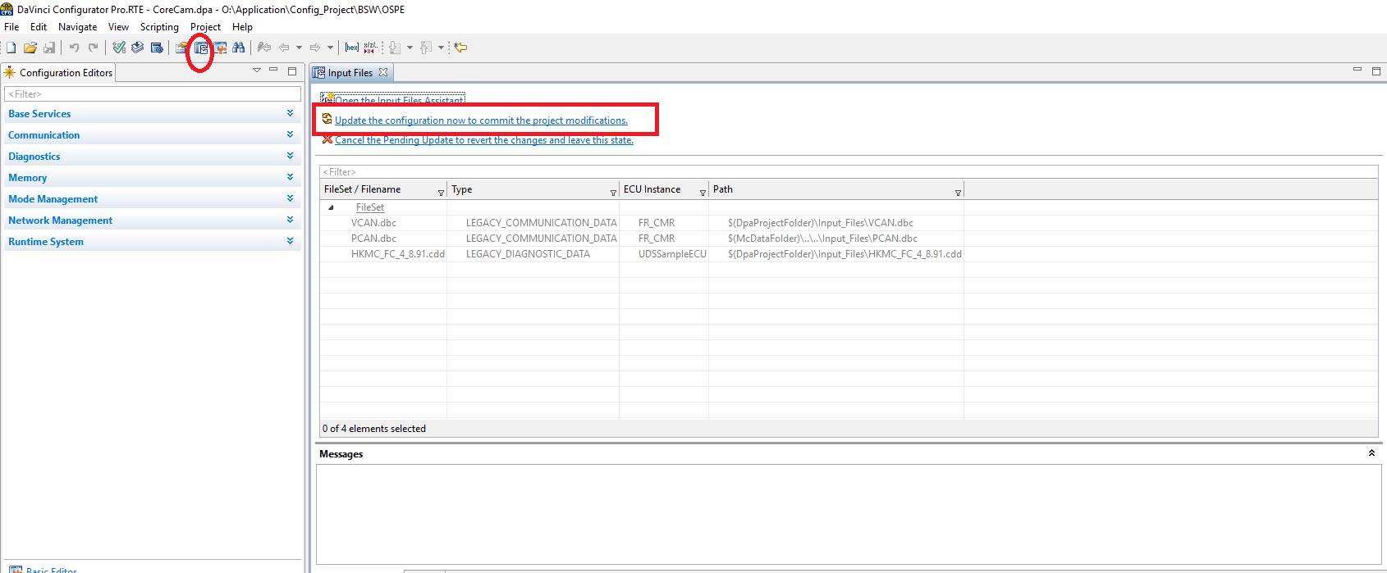

1. Update Configuration as complete process

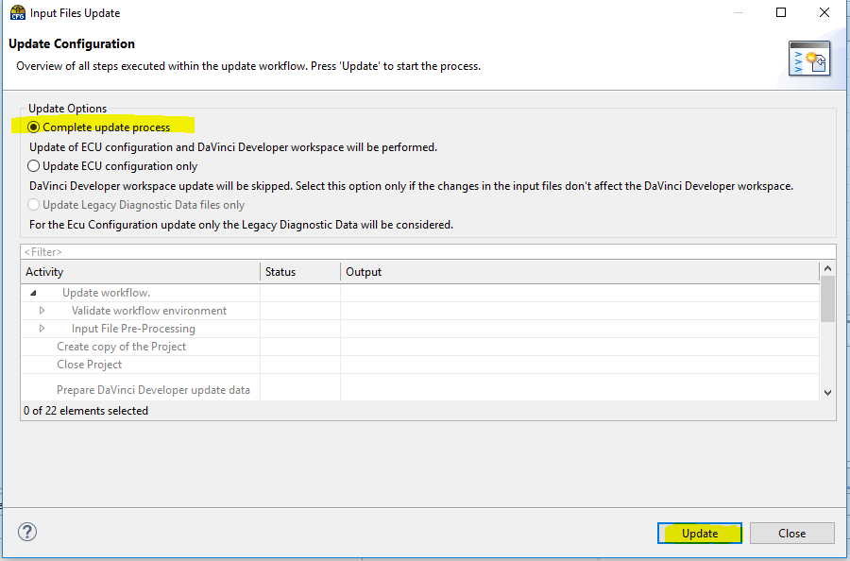

1. Once the update is complete then close the window

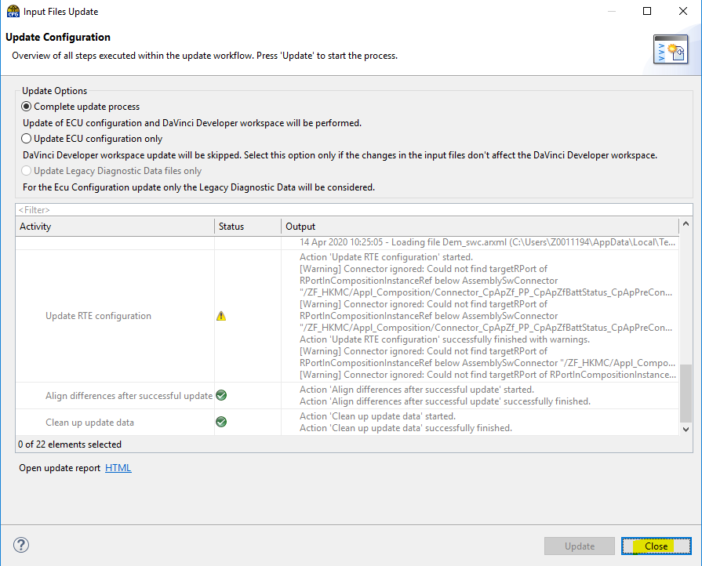

1. In DBC whatever we added new message (Here CLU22(0x5C2) it’s error is coming in PDUR level

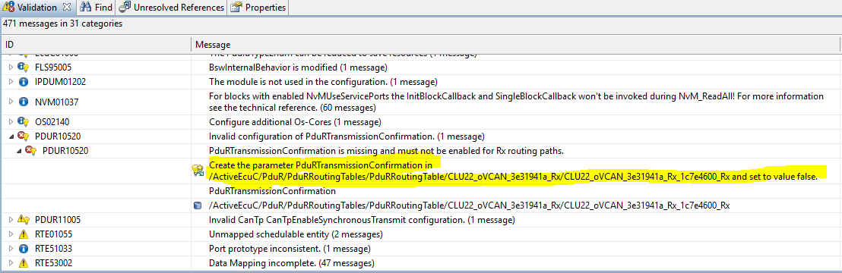

Reference of Receive message CLU22(0x5C2) in DBC and it’s signal



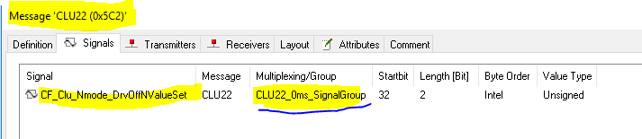

1. If we check what are the reference generated for CLU22 in Davinci Configurator, then search that message

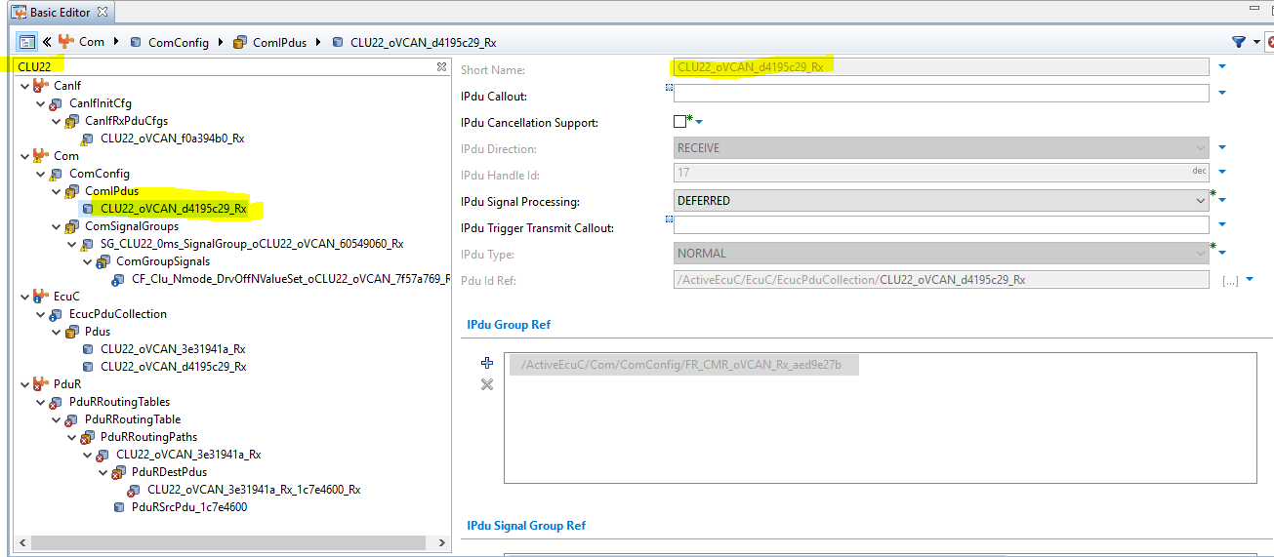

1. According to our requirement assign this message to Basic Can or Full Can buffer ,in here we are using Full Can so need to create buffer for that by using comIPdus name (“CLU22_oVCAN_d4195c29_Rx”)

* Here we are creating the receive hardware object by taking reference of CGW1 because it is also receive object , Hence we are duplicate the copy of CGW1.

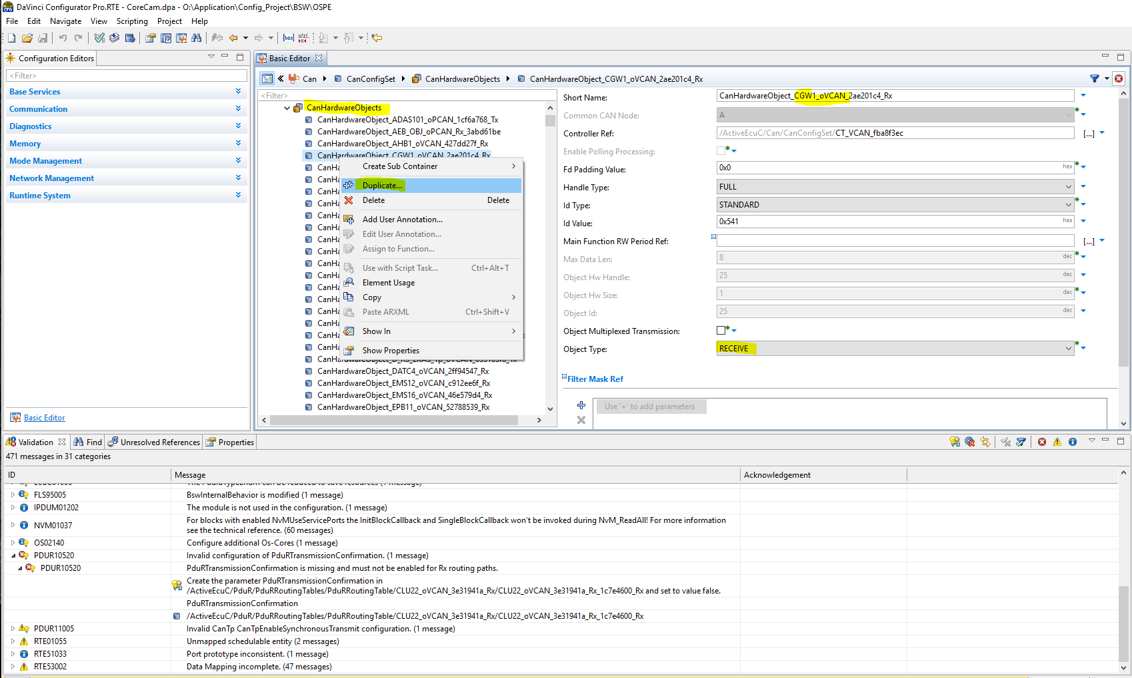

* It will ask how many duplicate copy of CGW1 we require ,Here in our case only one receive message CLU22 added hence we mentioned as 1

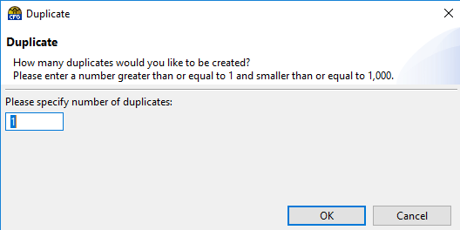

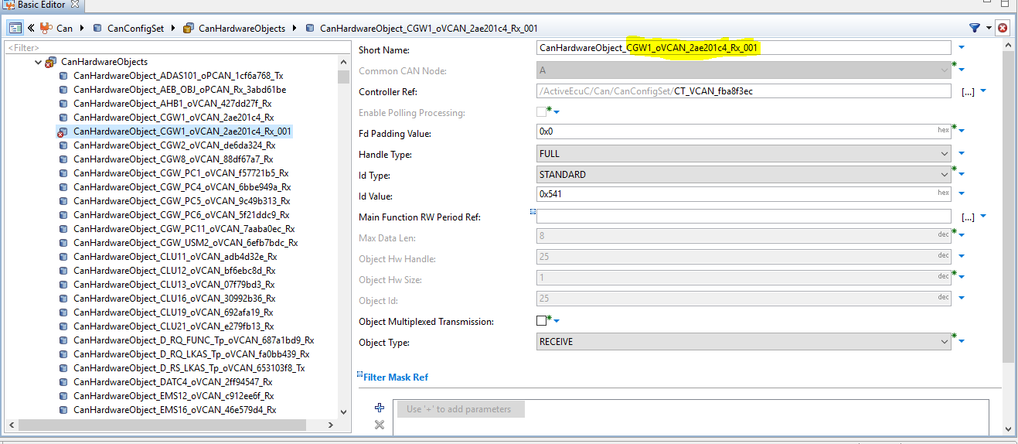

1. Replace “CGW1_oVCAN_2ae201c4_Rx_001” name with comIPdus name (“CLU22_oVCAN_d4195c29_Rx”) and it’s Id value (0x5C2)

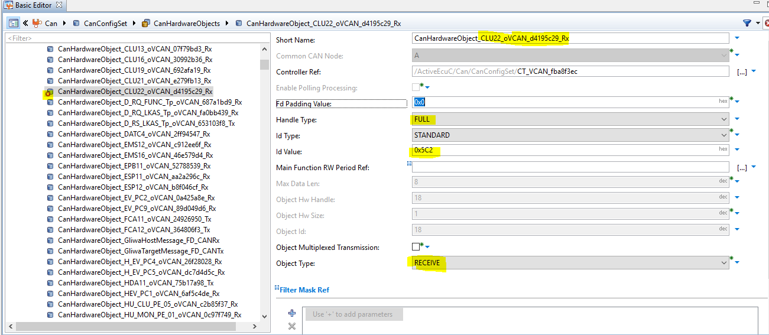

1. We have created hardware receive object but currently that is unused so we need to create hardware receive handle in CanIf ,We took the reference of CGW1 and create duplicate copy of 1.

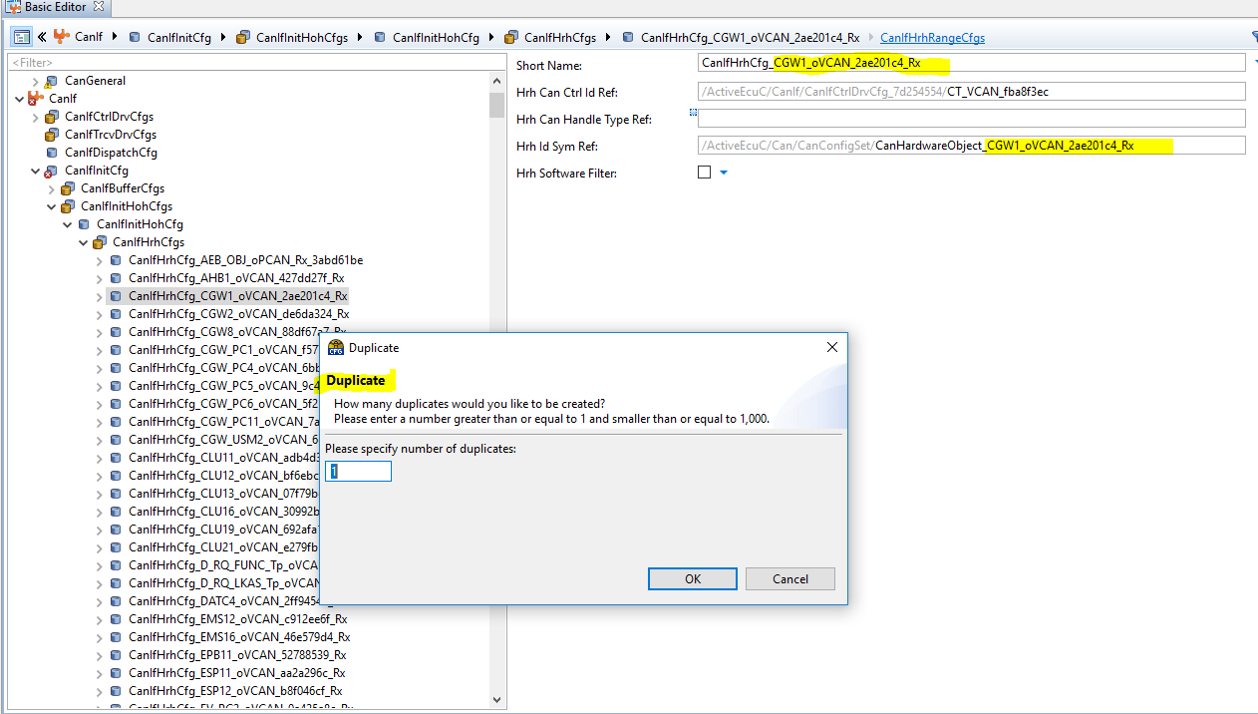

* Once the copy is available then replace CGW1 name with comIPdus name (“CLU22_oVCAN_d4195c29_Rx”) and select hardware receive handle id

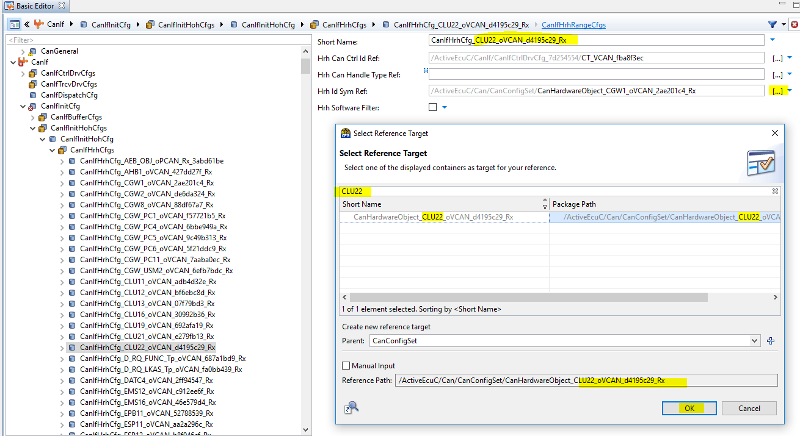

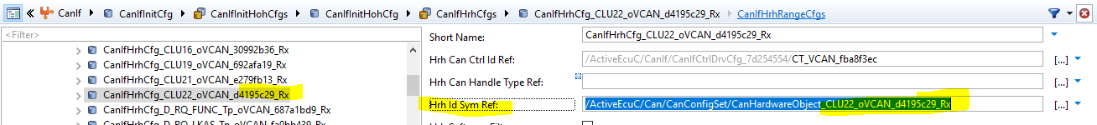

1. Assign CanIfRxPduCfgs CLU22(With is generated already when DBC imported) with proper Rx Pdu Hrh Id Ref: ,here need to assign CLU22

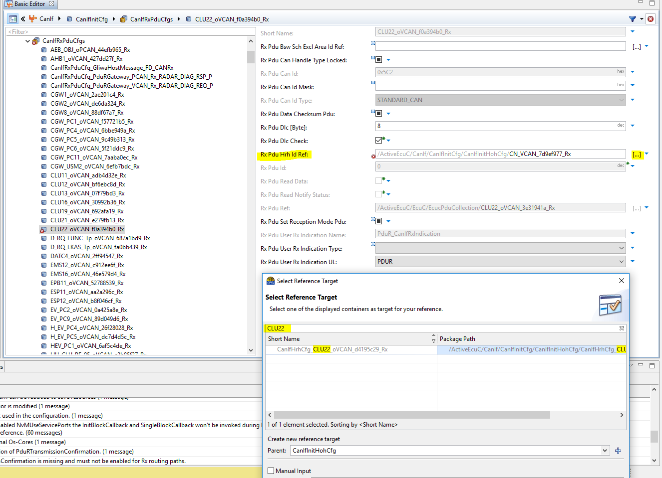

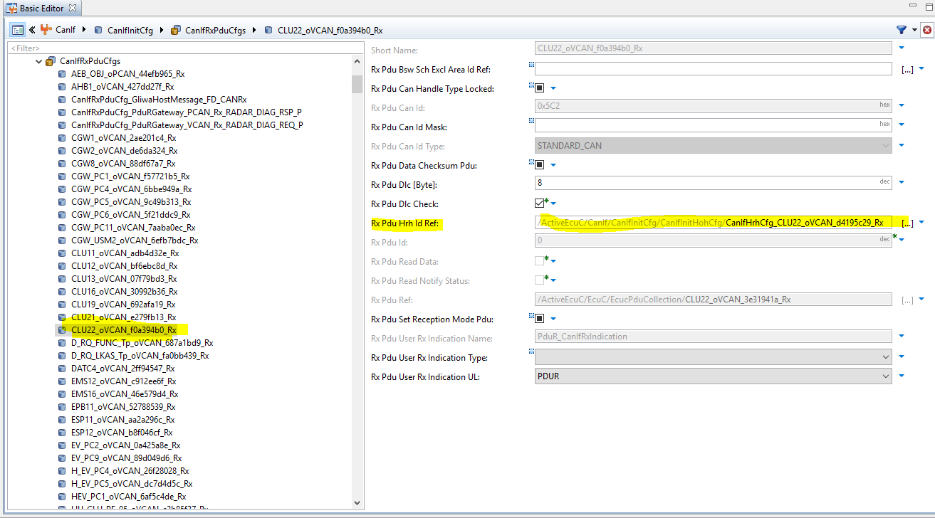

1. Check all paths are generated properly for CLU22 in each level (Can,CanIf,EcuC,PduR,EcuC,Com)

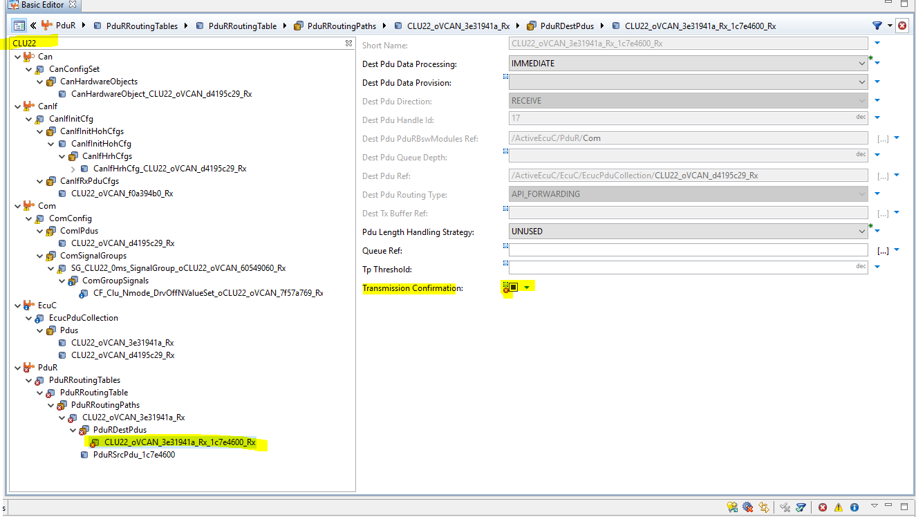

1. Some property changes require for CLU22
2. Transmission property in PduR level need to remove because it is receiving

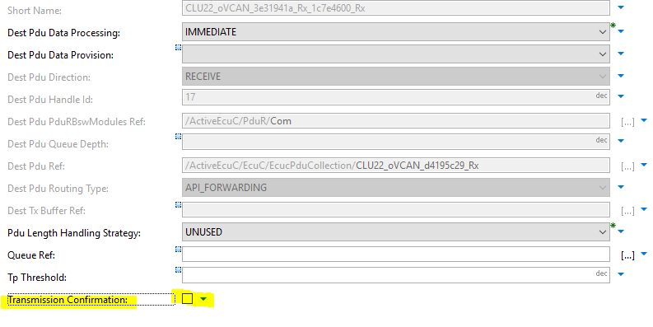

1. In ComSignalGroups for signal group,

‘SG_CLU22_0ms_SignalGroup_oCLU22_oVCAN_60549060_Rx’ ,Signal group Access is ACCESS_UNCLEAR ,and for signal

‘CF_Clu_Nmode_DrvOffNValueSet_oCLU22_oVCAN_7f57a769_Rx’ ,signal Access is ACCESS_UNCLEAR change it to according to requirement ,here we will change it to ACCESS_NEEDED_BY_SWC_OR_COM

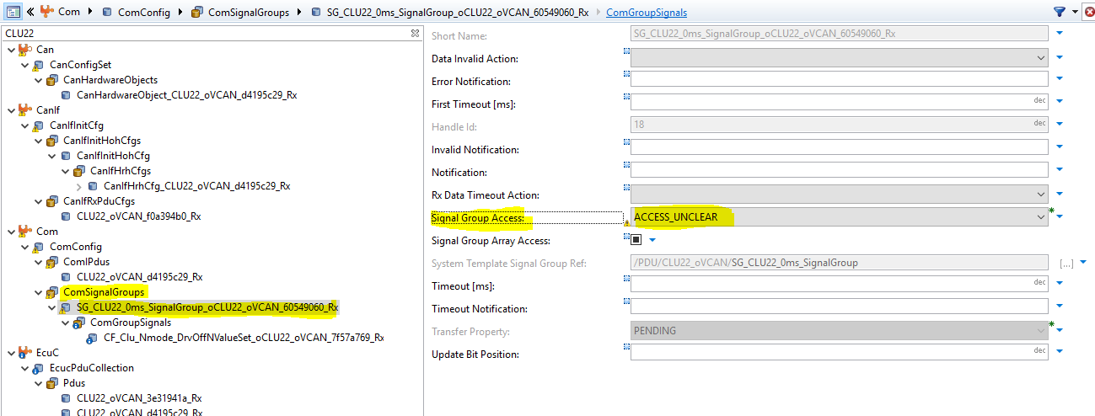

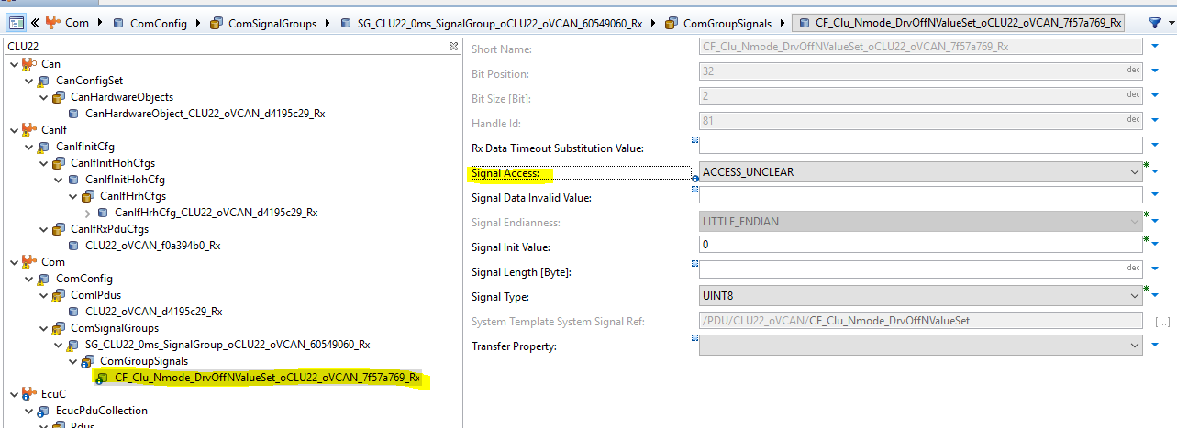

After change

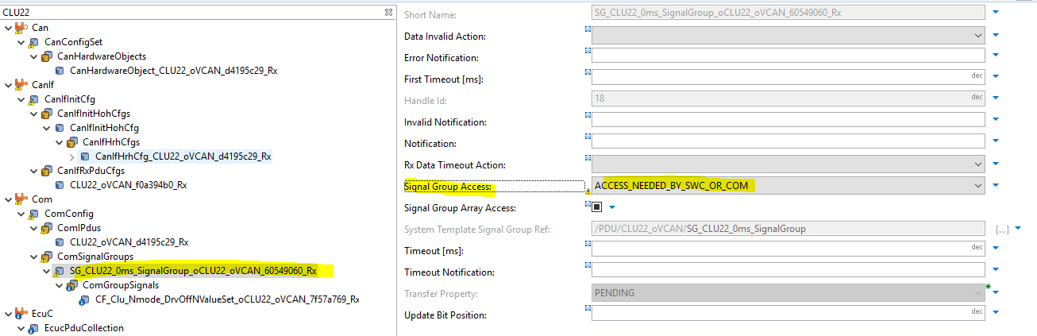

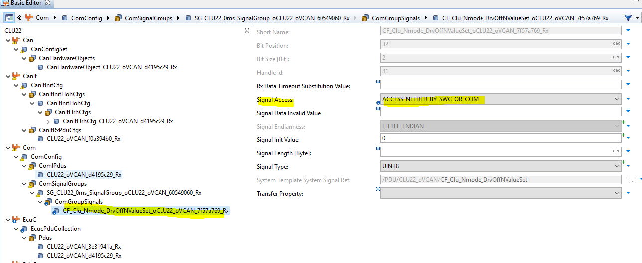

1. Once these things done then check there is no issue now

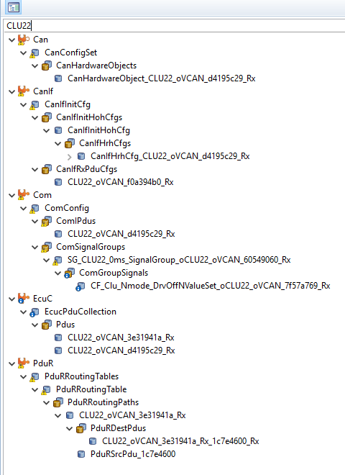

1. Validate the code once again in Configuration level

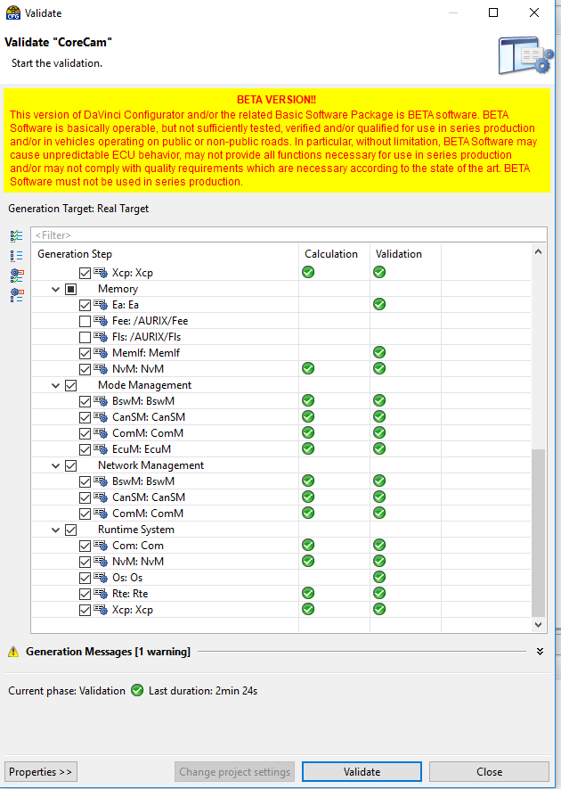

**Note:** For Dem level some errors are coming for some DTC for “DemDebounceAlgorithmClass “due to vector sip limitation,change it toDemDebounceMonitorInternal and delete DemDebounceCounterBased, Check below two images one with error and another after removing error

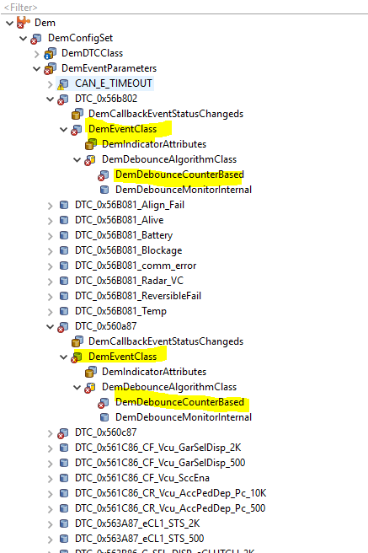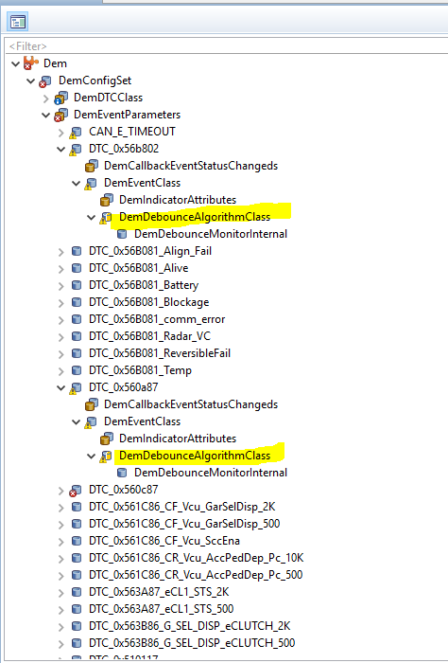

Up to this this level message and signal is available in COM layer there is no reference of this in file ‘ Rte_Application_OsCore_Core1.c’, ’ Rte_Cbk.h’,’

Rte_Hook.h’, ’ Rte_Type.h’, ’ Rte.c’, ’ Rte_CpApVCan.h’

so, we need to connect or transfer this message above COM (i.e. Rte and SWs component)

once the connection proper then reference will generate as above mentioned file, check below image also

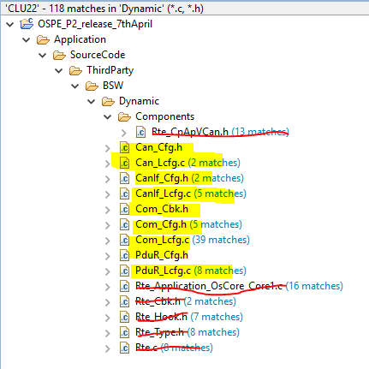

1. Now Signal is available in COM layer, so we need to make Data mapping (Below RTE it is signal and Above RTE it is data) Before that we will check what are default properties are available

* If we check Data Mapping tab inside this Network signal (SG_CLU22_0ms_SignalGroup, SG_CLU22_0ms_SignalGroup.CF_Clu_Nmode_DrvOffNValueSet) available but there is no Port and DEP/Operation/Trigger available

Check below image in ‘signal View Mode’(~ )

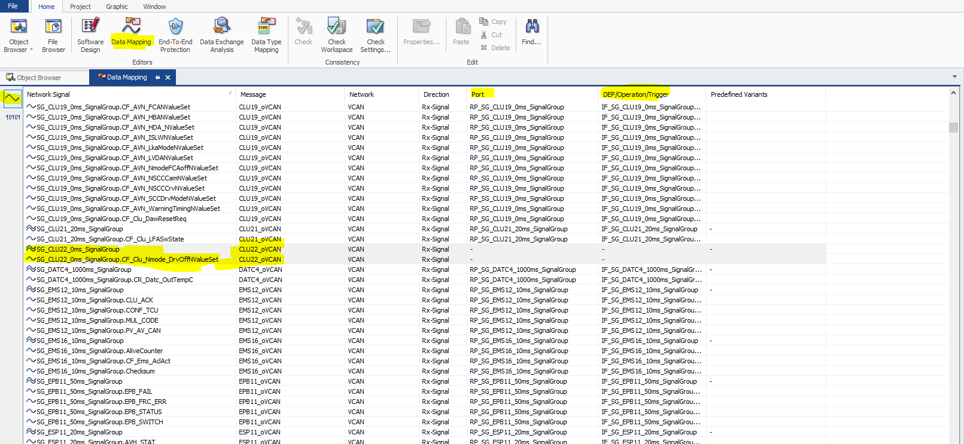

Port Element View Mode (10101) there is no reference of CLU22 and in search window also no reference(Red Arrow)

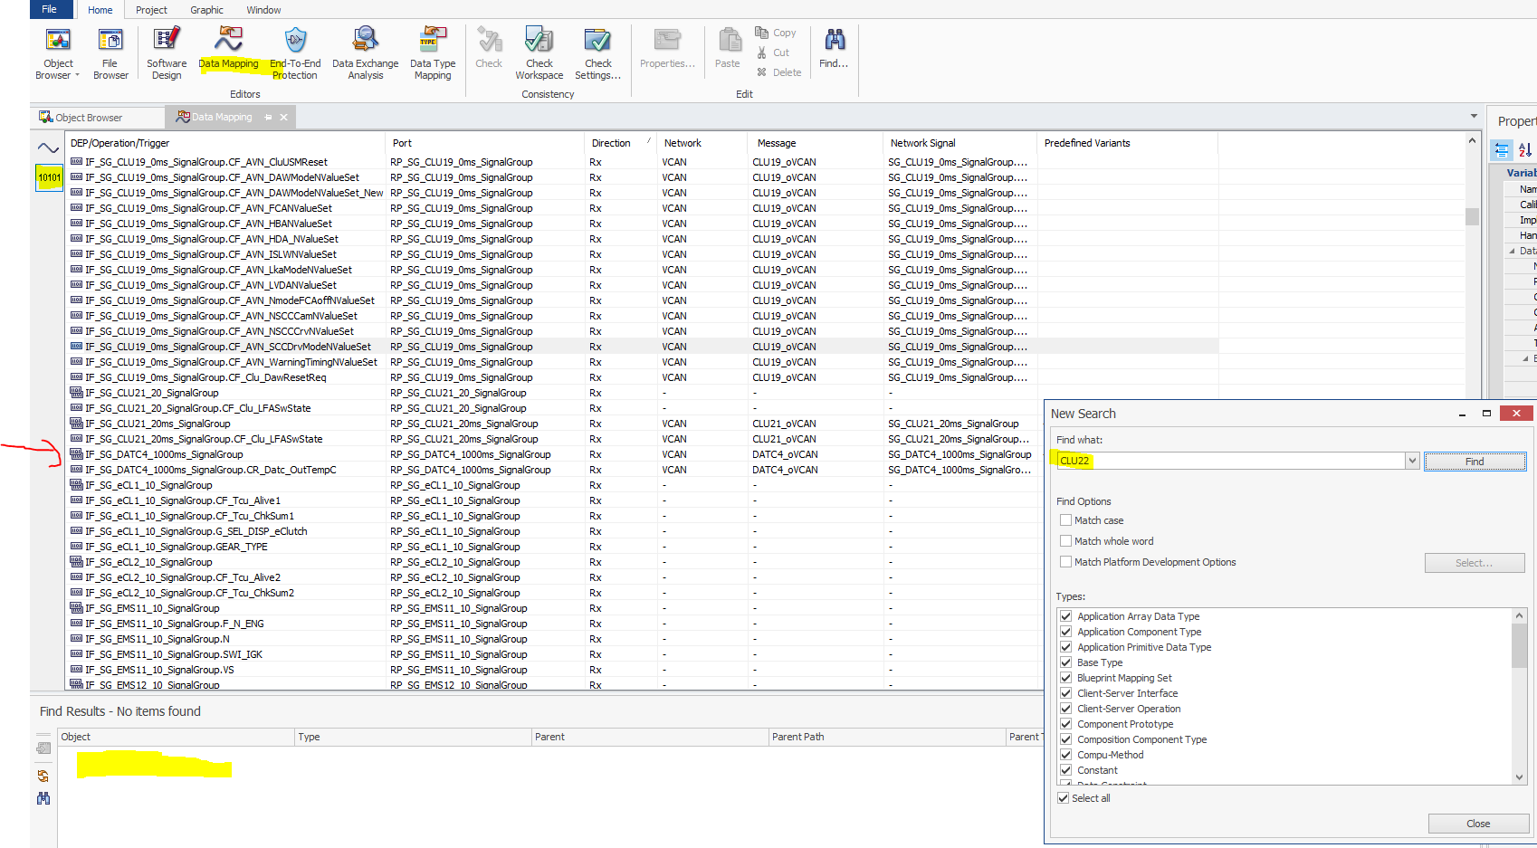

* Whatever signal is in COM layer it’s Compu Method is generated in the form of “CM_CF_SignalName”

Here ‘CM_CF_Clu_Nmode_DrvOffNValueSet’

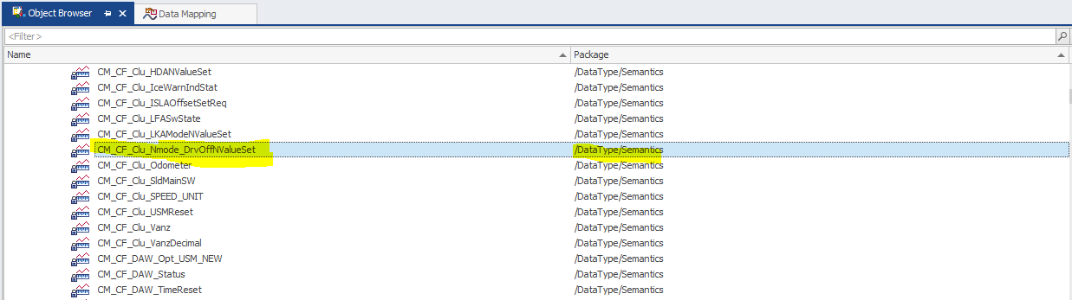

Signal Name properties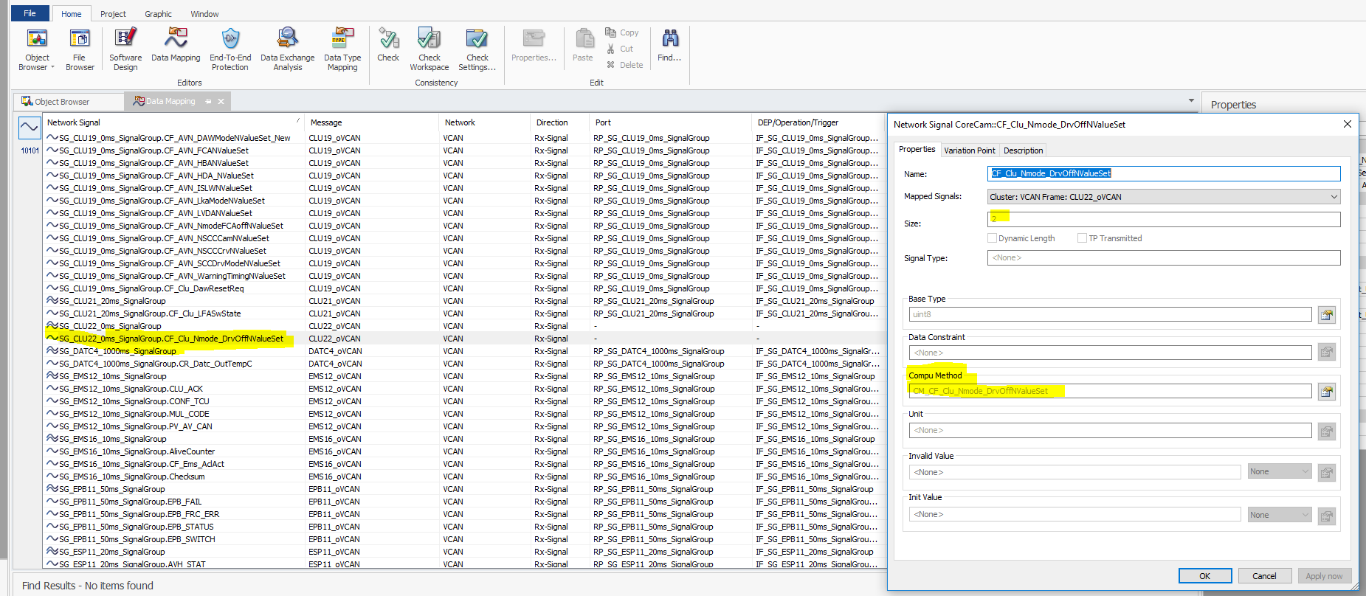

Signal Group Properties

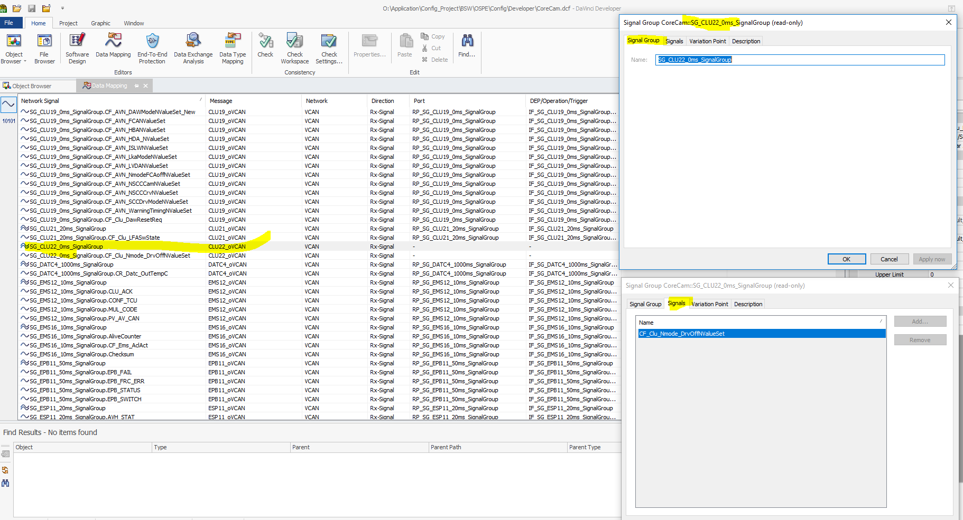

1. ‘Create Port Prototype’ in signal view mode (Right click on signal group “SG_CLU22_0ms_SignalGroup)

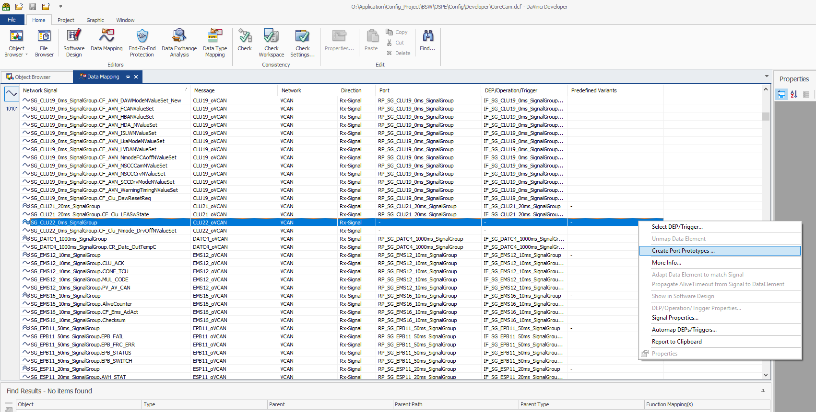

Write Prefix and Postfix as mentioned in below image of ‘Create Port Prototypes’

Here Port Prototype mentioned as RP_ because it is receive message, for transmit it should be PP_

Port Creation as “ECU Delegation and Software Component Ports” and Component Prototype as Appl_Composition

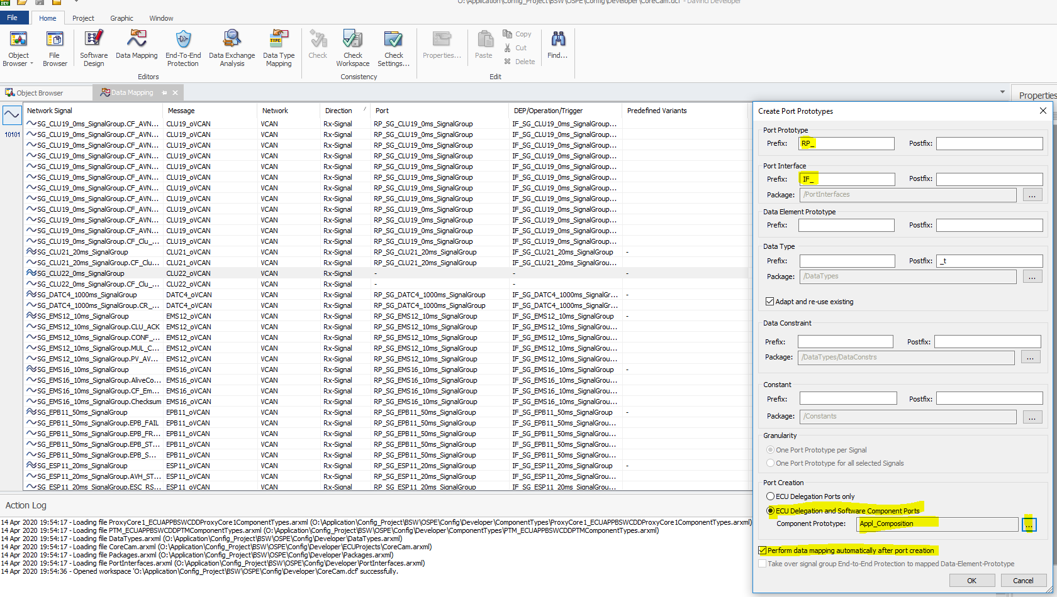

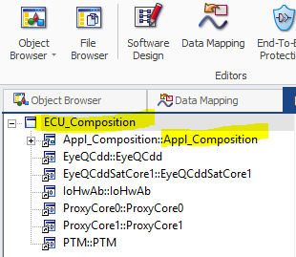

* After Port and DEP/Operation/Trigger in “Signal View Mode”

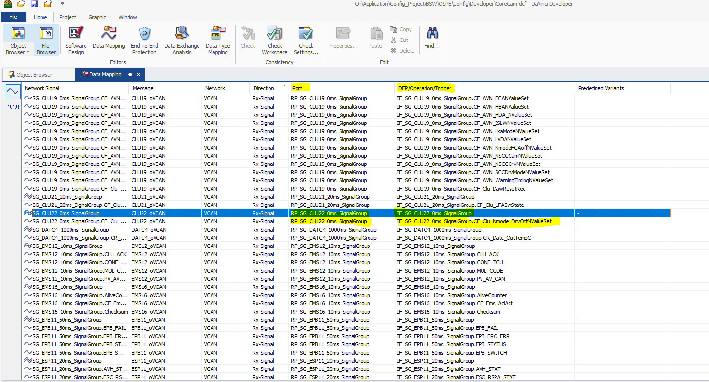

* After Port and DEP/Operation/Trigger in “Port Element View Mode”

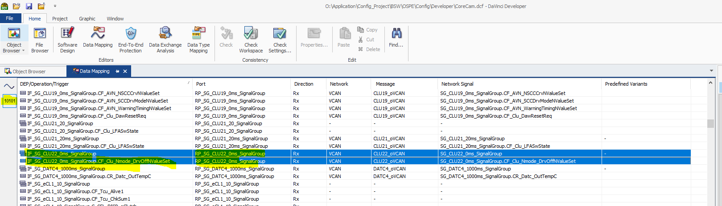

* Now Search message CLU22

One receive port at ECU_Compostion level and one at Appl_Compostion level

Interface created for Message and it also represents signal within that.

Implementation Data type also created for this (SG_CLU22_0ms_SIgnalGroup_t)

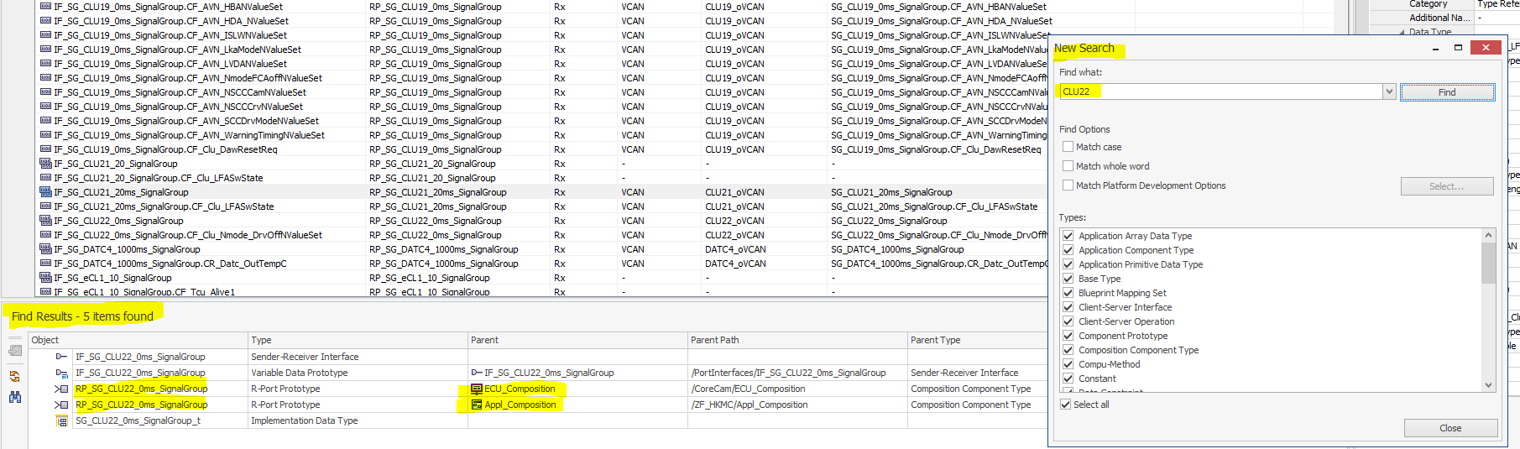

* Check Interface properties for IF_SG_CLU22_0ms_SignalGroup

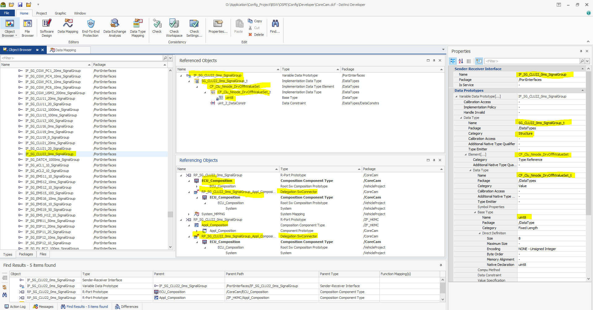  
- If we check Referencing Object window two interfaces are created

1. For ECU_Composition level
2. For Appl_Compostion level because we selected Create Port Prototype as below.

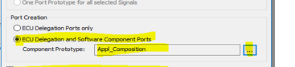

For ECU_Composition level Receiver port

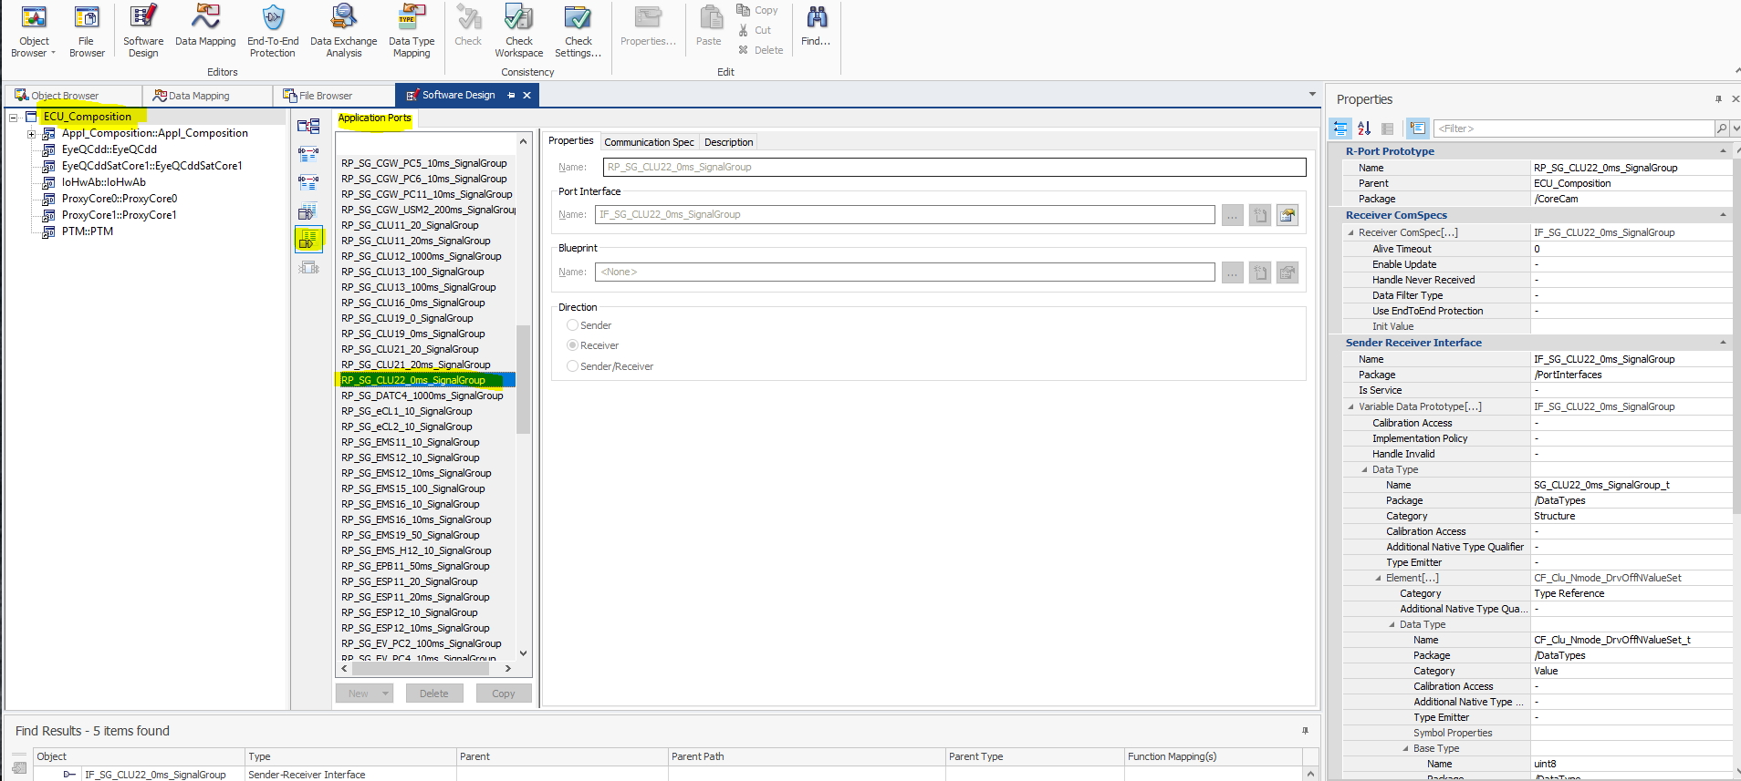

For Appl_Compostion level Receiver Port

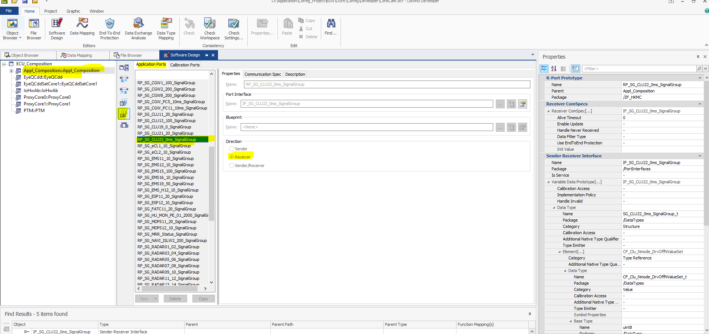

After this the signal Group is created in RTE layer Rte_Type.h(SG_CLU22_0ms_SignalGroup_t) not any other layer

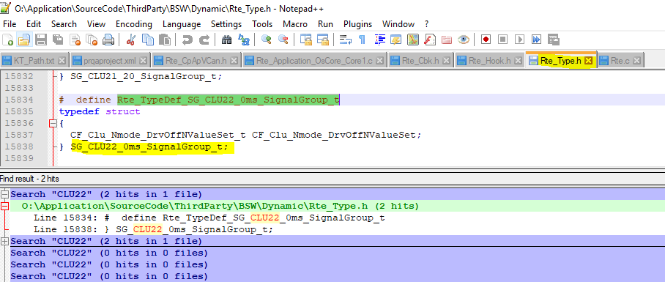

1. Create Receiver Port on require component

(Here We are creating receiver port for CpApVCan Software Component)

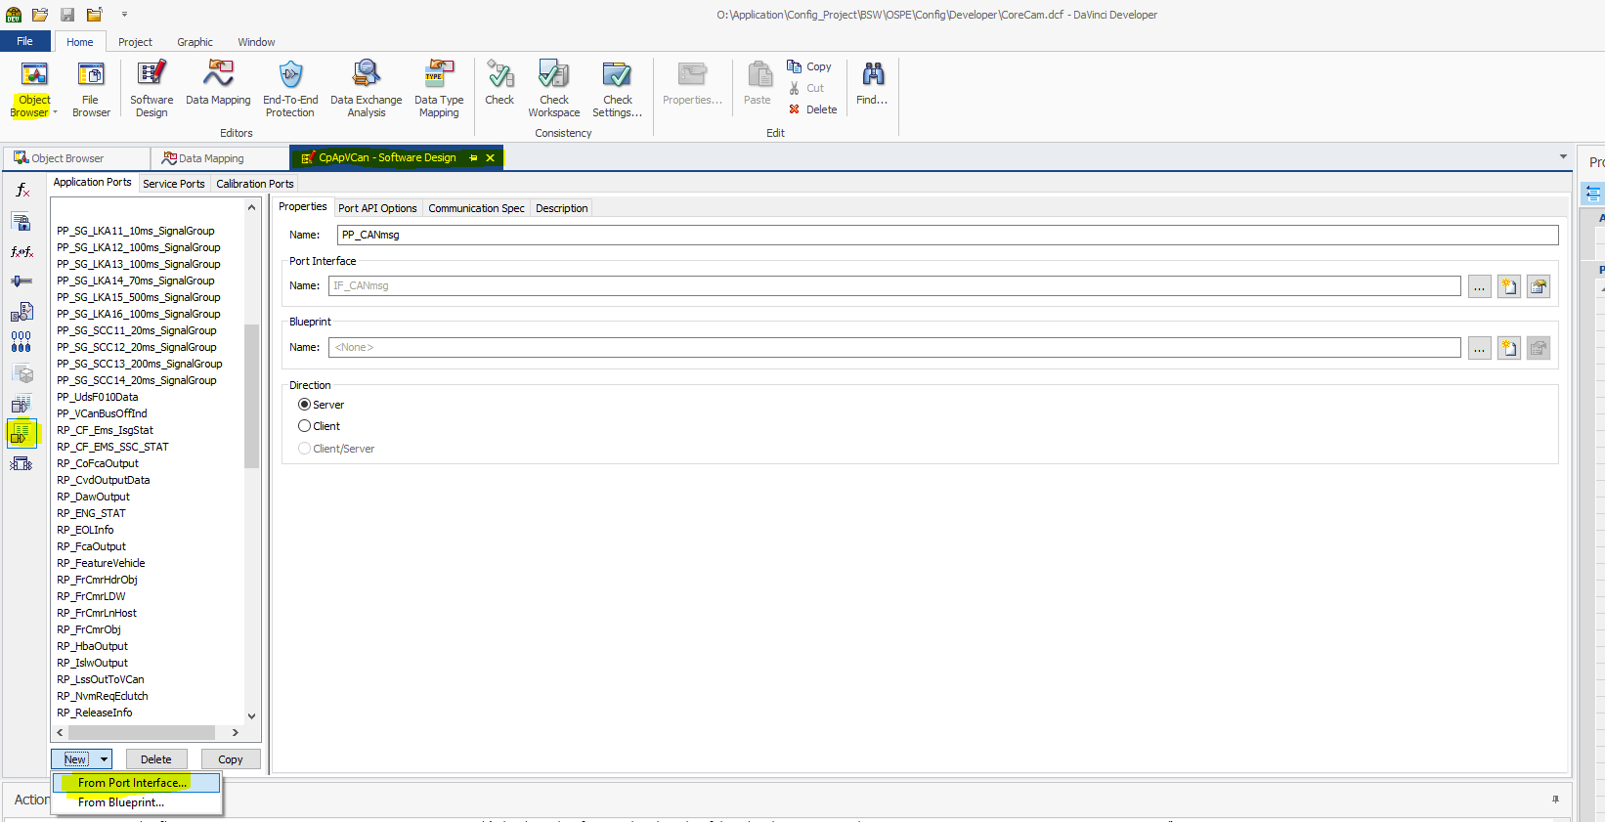

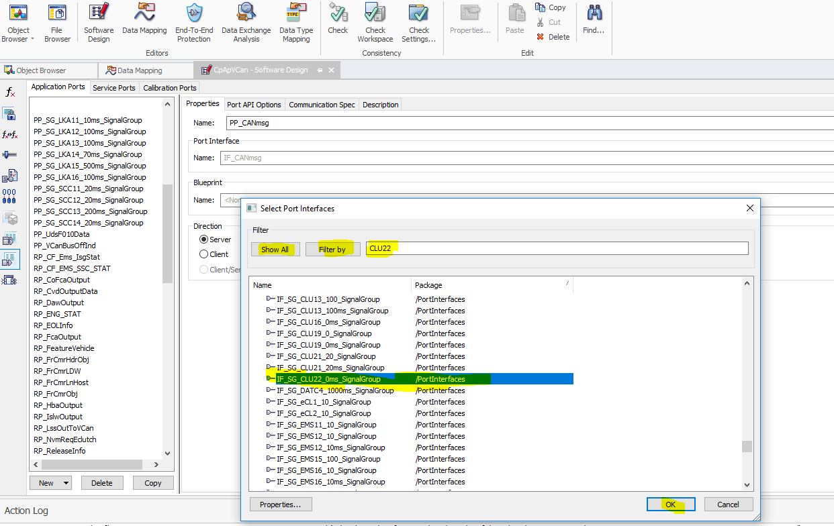

* While it is generating New From Port Interface, it is generating Direction as Sender port and Port name is same as Port Interface name “IF_SG_MessageName_SignalGroup”( IF_SG_CLU22_0ms_SignalGroup) ,

So, Change Direction (Receiver) and Port Name (RP_SG_CLU22_0ms_SignalGroup) as per our requirement

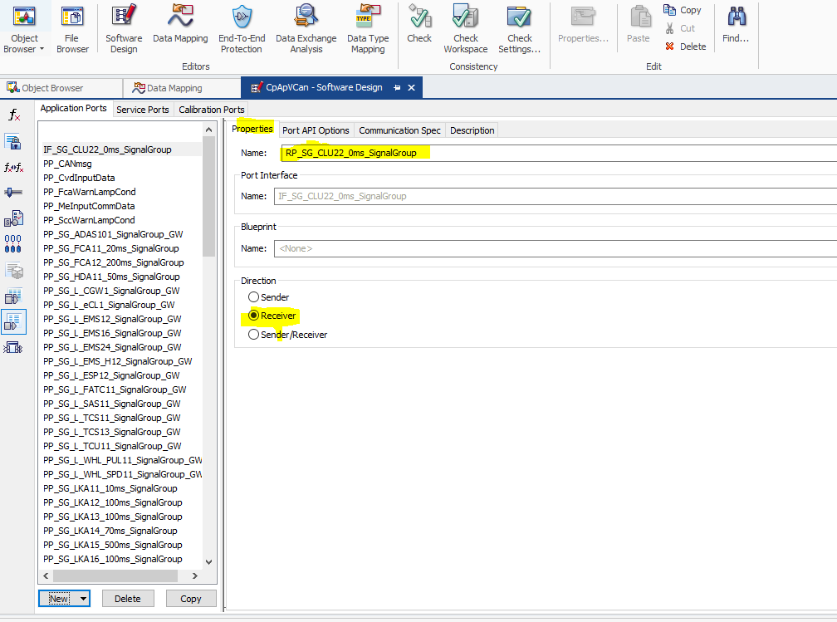

* By Default, Communication Spec Properties for Receiver ComSpec as below

Init Value is None and Enable Update is unchecked ,so change this according to requirement

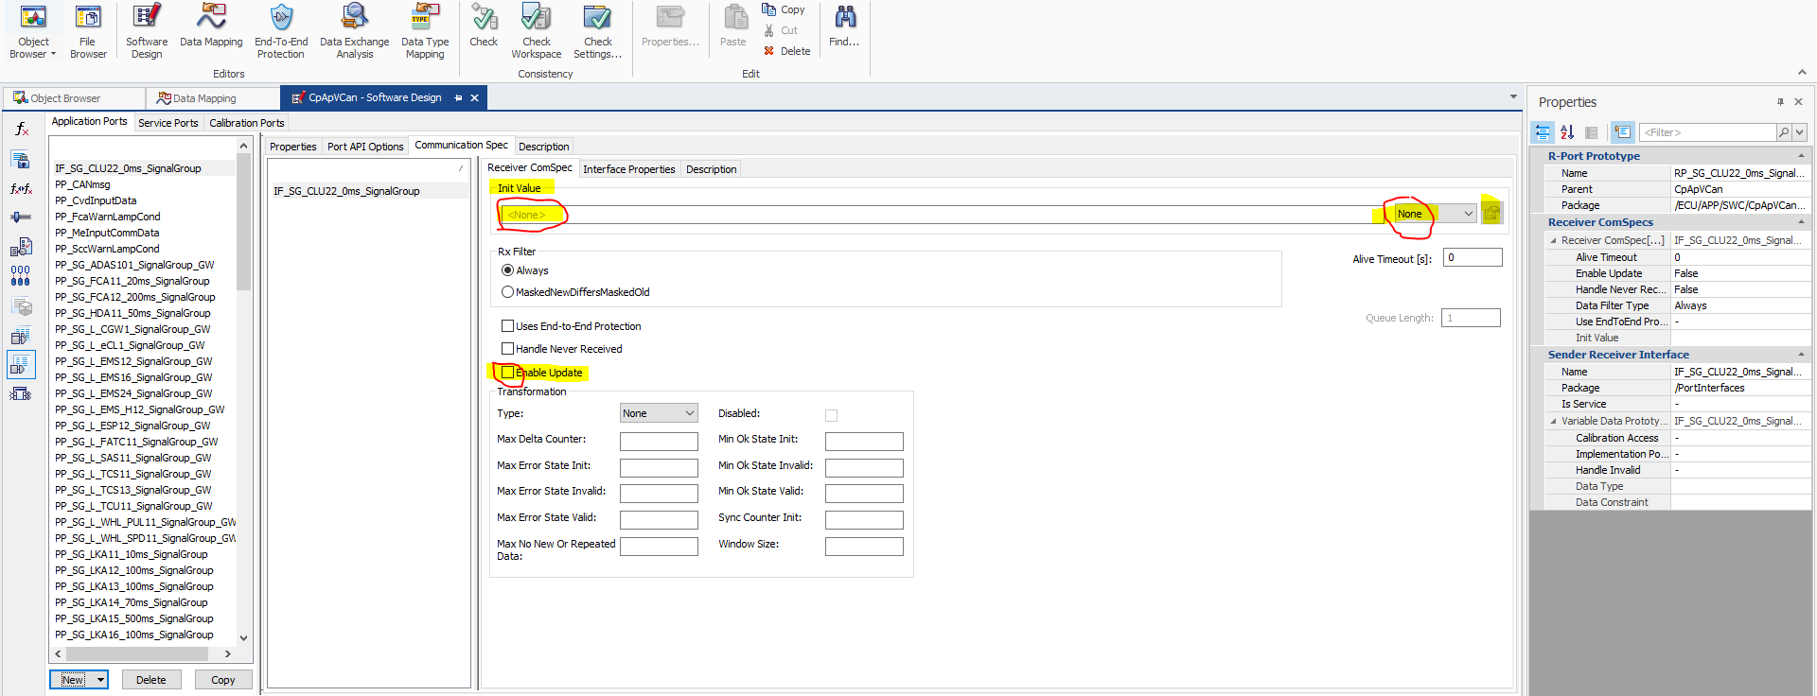

So, as per out requirement changes

Init Value is ‘0’ and it is type of Record and Enable Update is checked

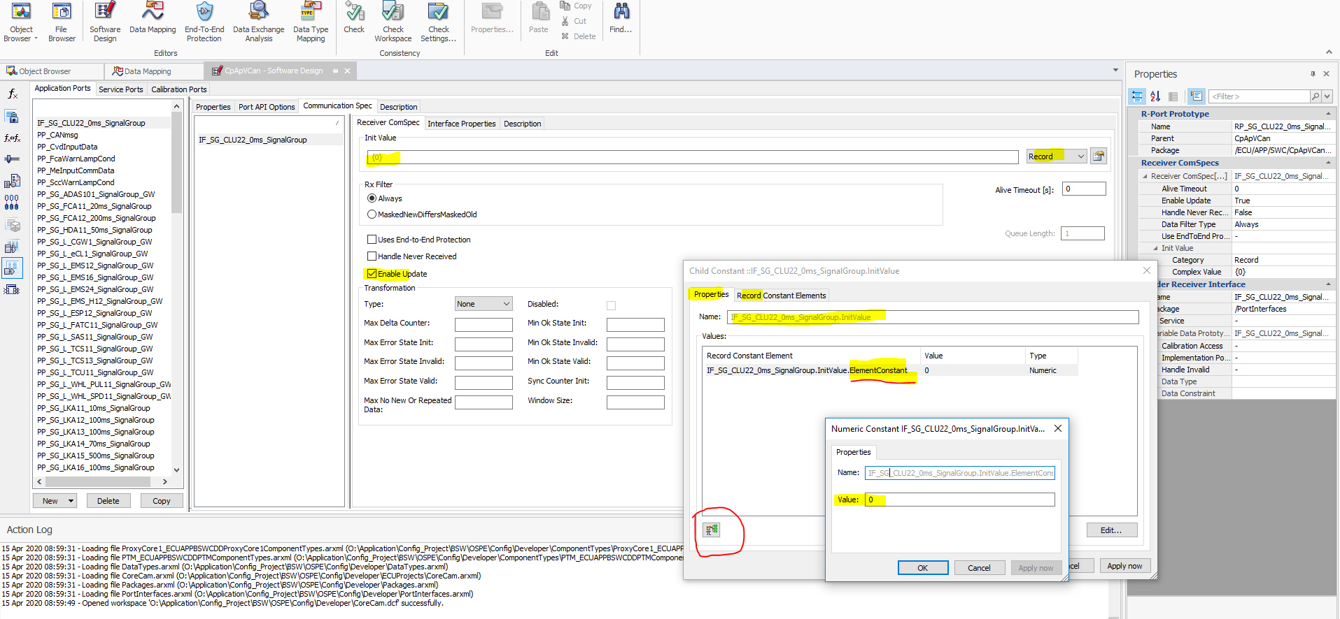

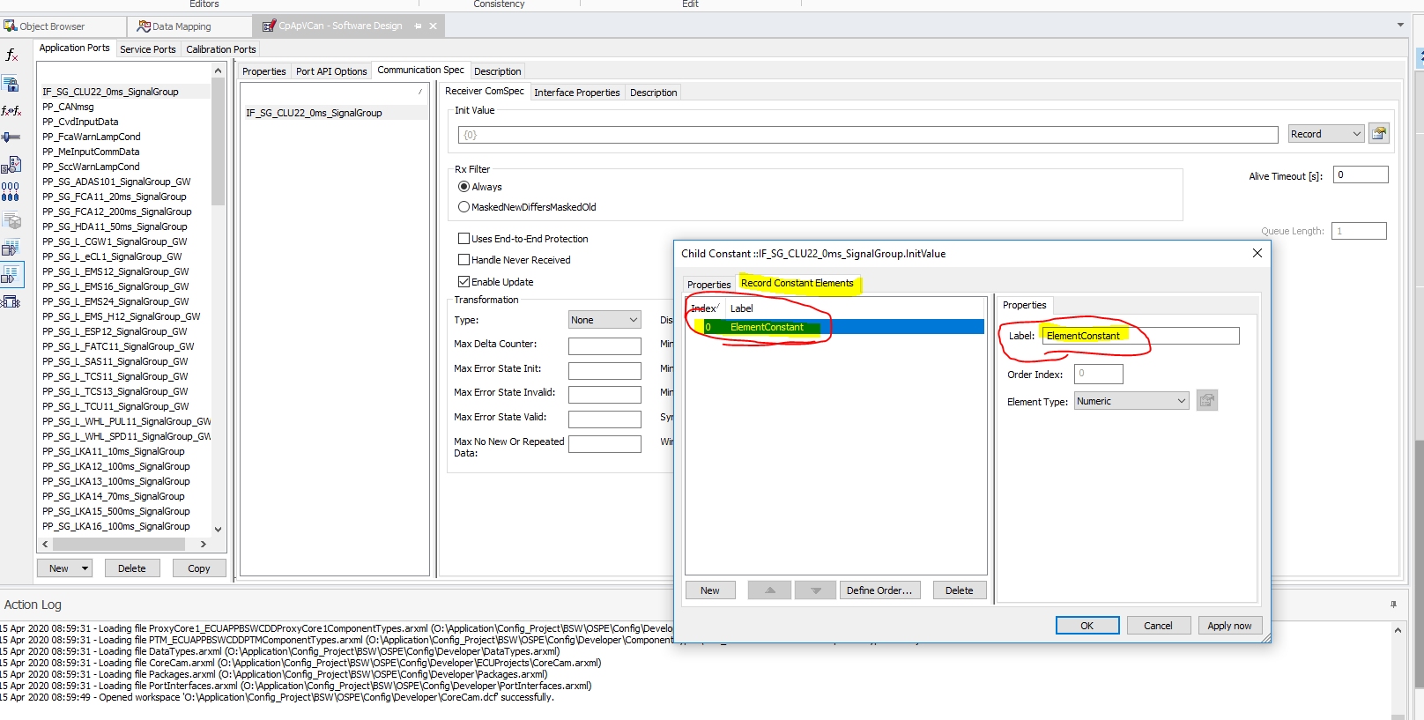

* Adapt structure of record type

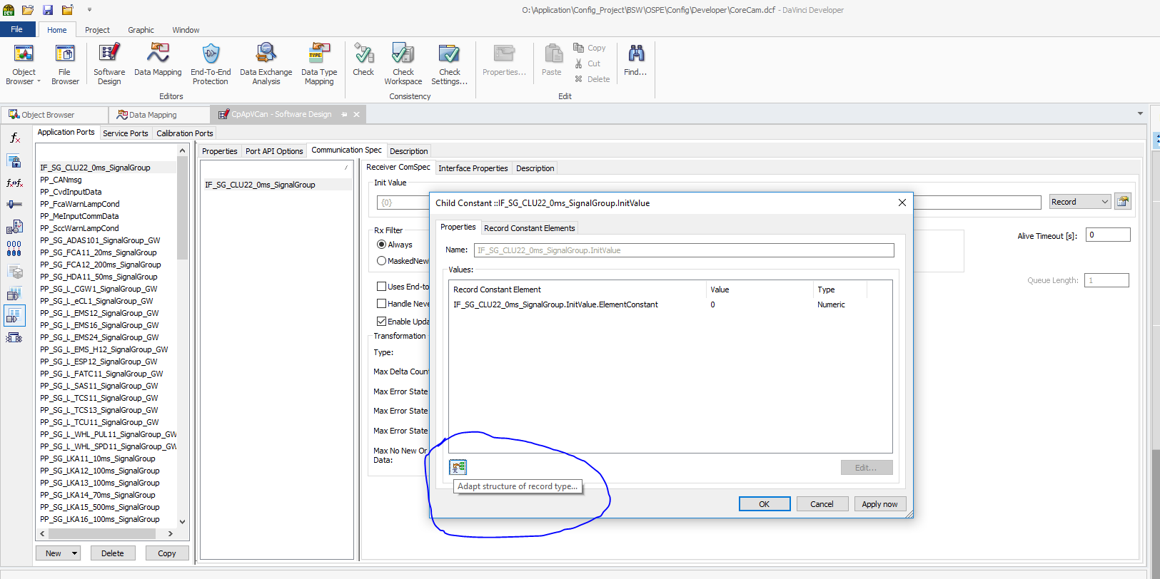

If we Adapt structure of record type then record element will update according to signal name in message

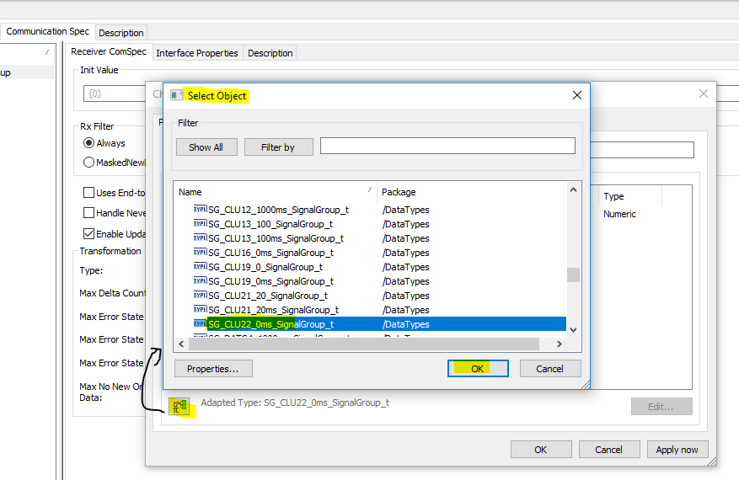

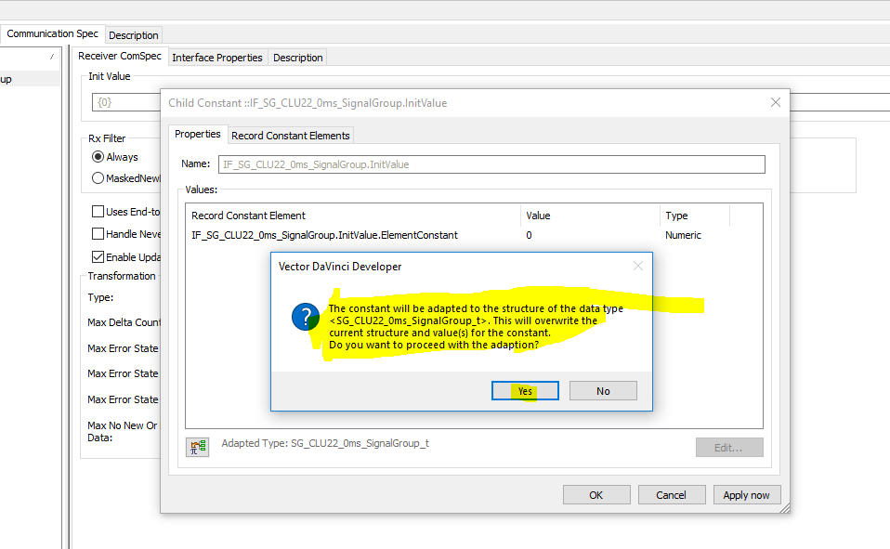

Check in Record Constant Element is updated with signal name (IF_SG_CLU22_0ms_SignalGroup.InitValue.**CF_Clu_Nmode_DrvOffNValueSet**) ,if proper then Apply now

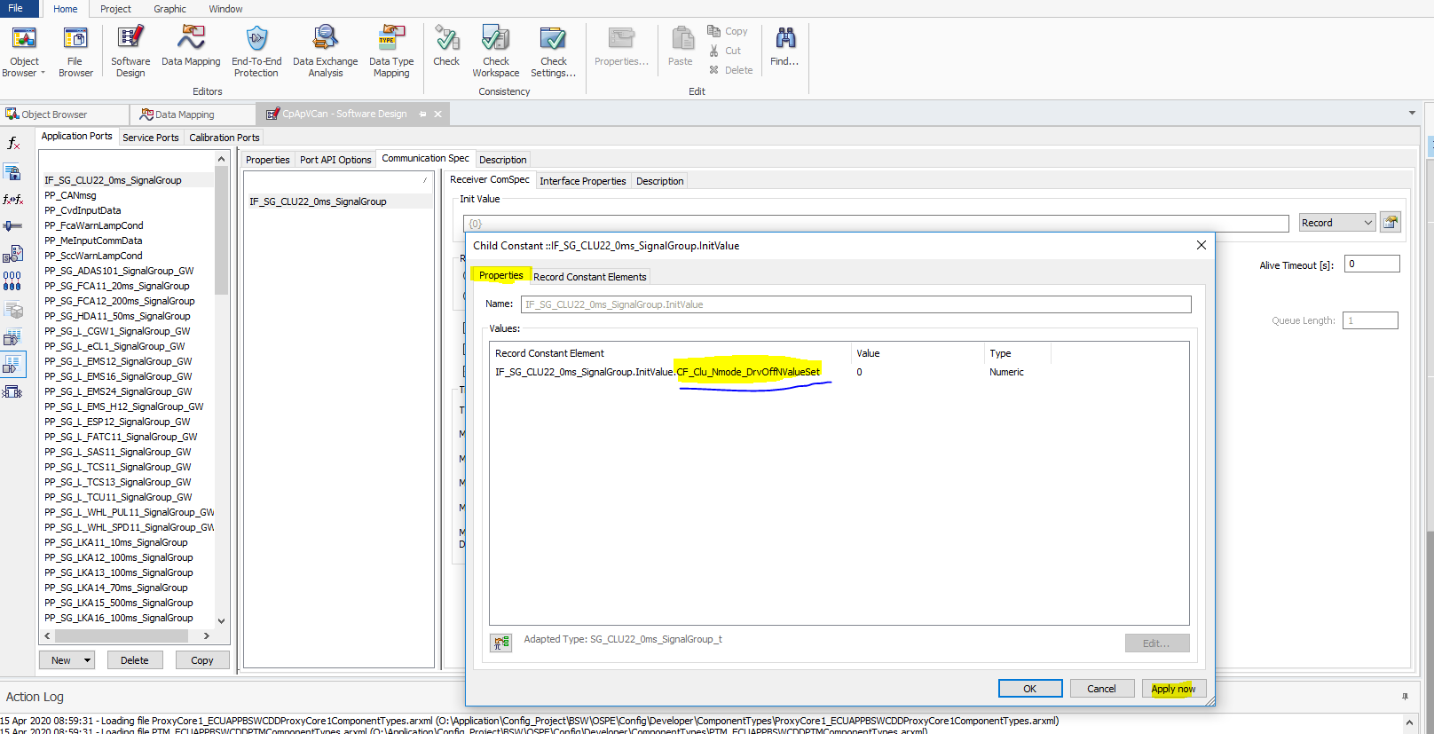

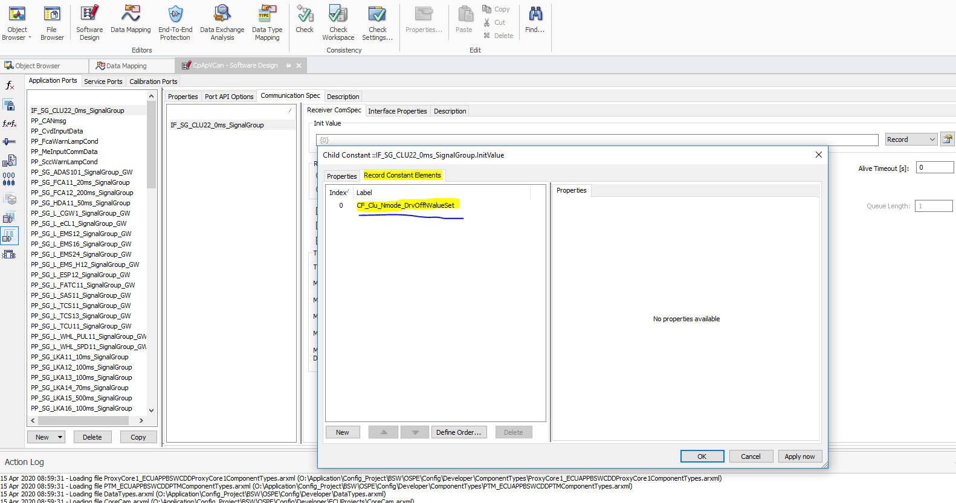

So in search you can check Port Interface added sucessfuly for CpApVCan

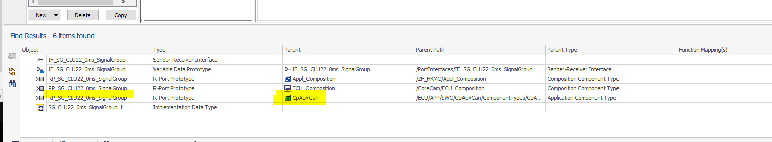

1. Due to above changes Configurator will ask for Synchronize Configuration now.

So Synchronize it and generate the Code

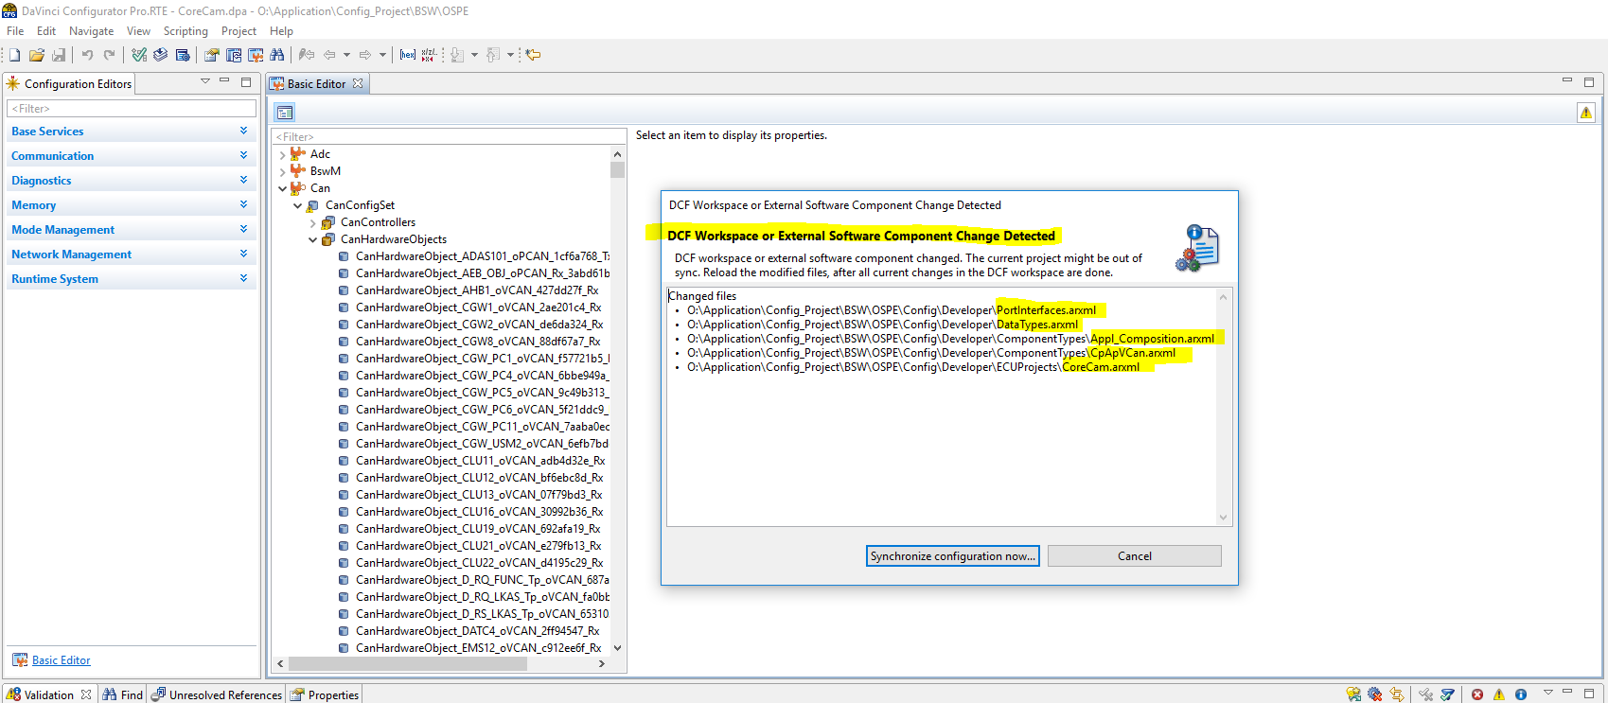

So, after generation only two file has reference of CLU22,

1. Rte_Type.h = Structure of message CLU22 added (**SG_CLU22_0ms_SignalGroup_t**)

Created Structure variable of message CLU22 ,call it as Rte variable

**Rte_C_SG_CLU22_0ms_SignalGroup_t_0**

Rte.c = The above Rte structure variable(**Rte_C_SG_CLU22_0ms_SignalGroup_t_0)** initialize as per we mention in developer

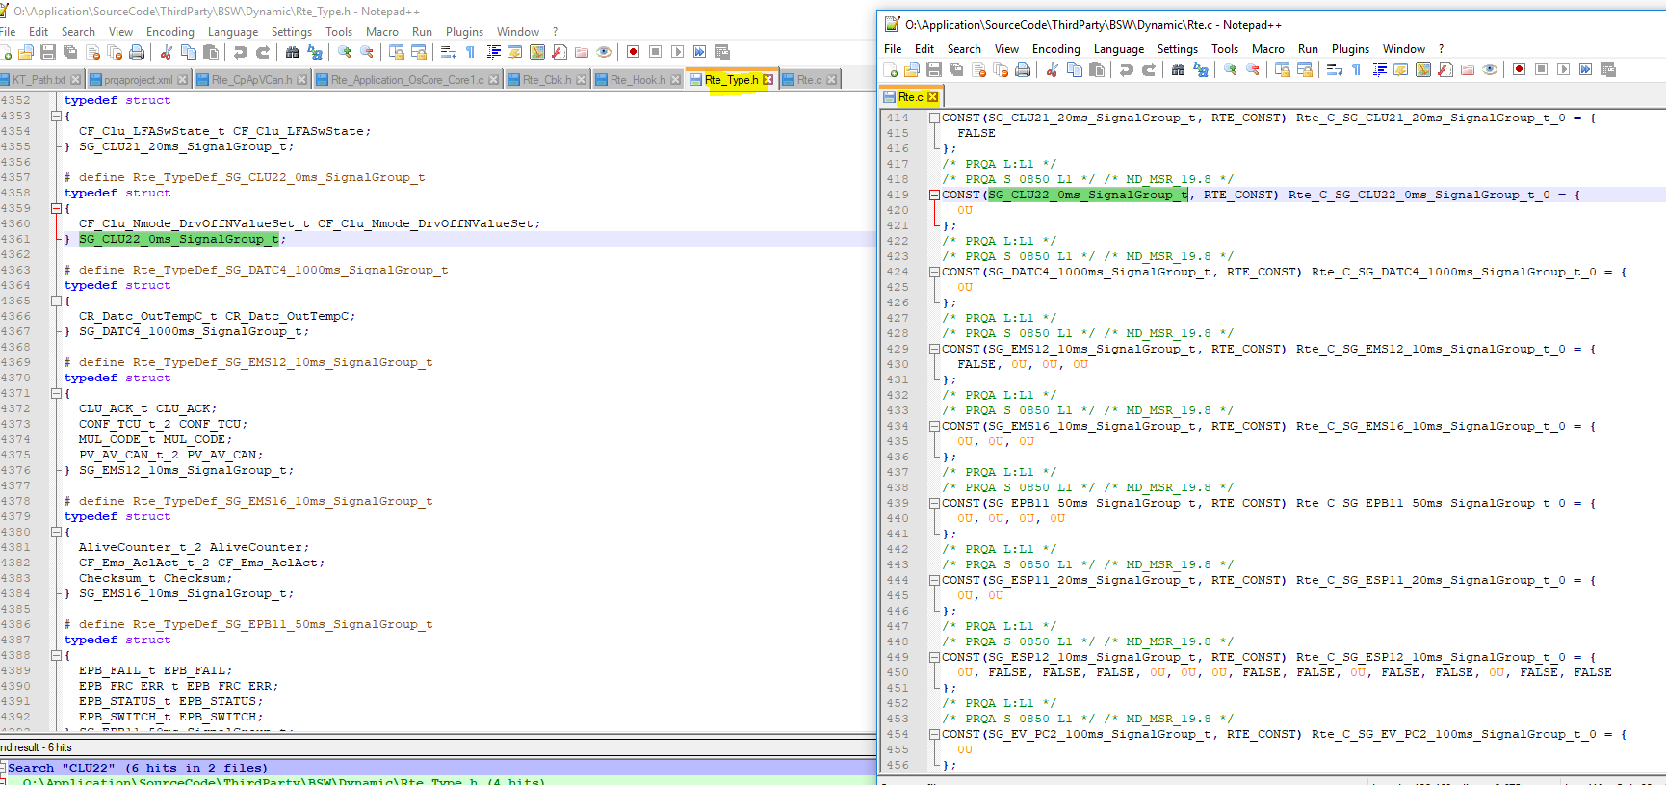

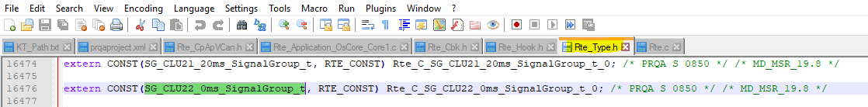

18) Whatever receiver port is available in CpApVCan need to connect in Runnable

Here we are connecting Port RP_SG_CLU22_SignalGroup to Runnable Re_CpApVCanMain

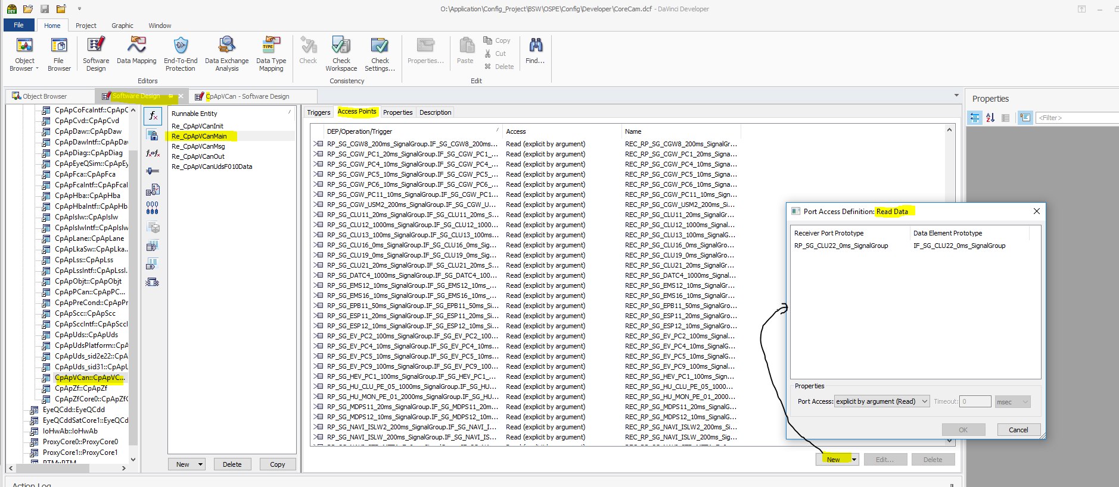

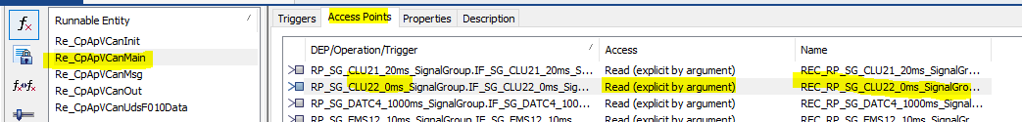

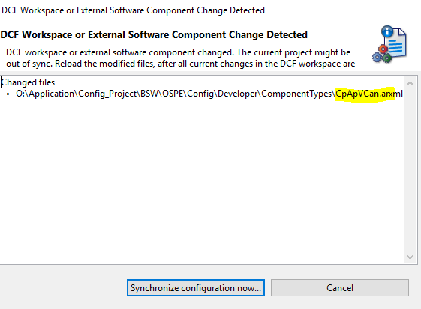

Due to above step below files updated

1. Rte_CpApVCan.h --> New Read port and it’s IsUpdated port information added.
2. Rte_Application_OsCore_Core1.c --> As CpApVcan Main function mapped to OsCore1

Hence here unconnected port created

1. Rte_Hook.h --> all part in comment section now.

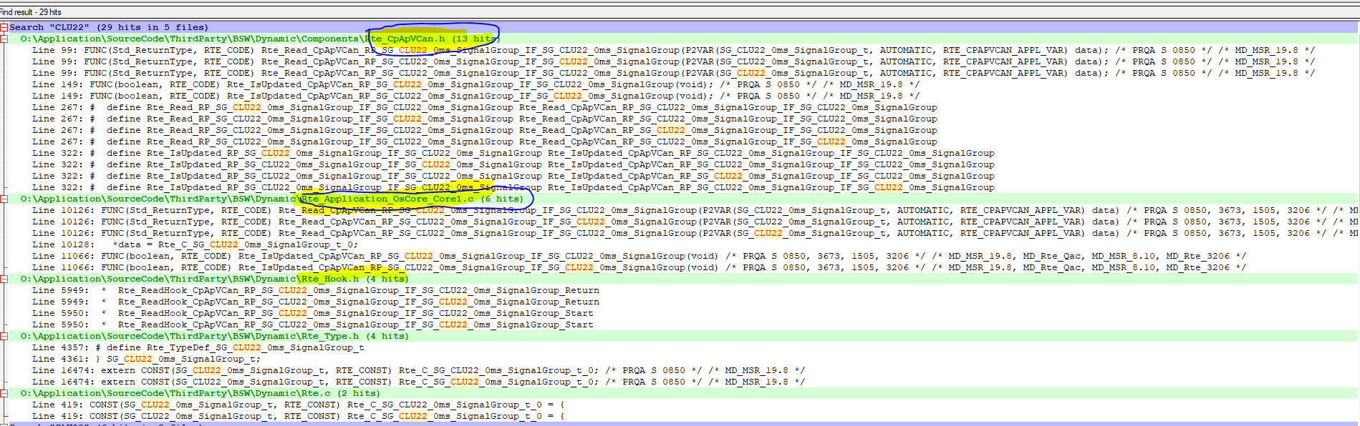

Rte_Application_OsCore_Core1.c

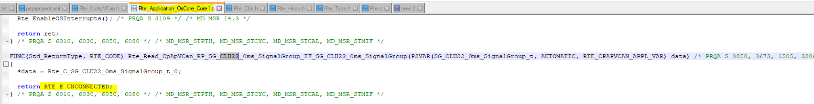 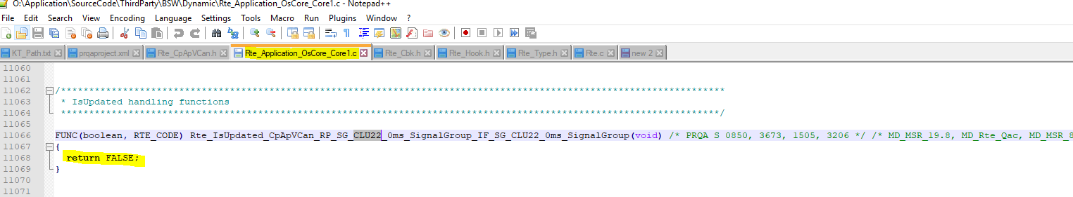

Rte_CpApVCan.h

 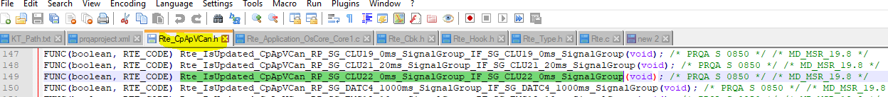 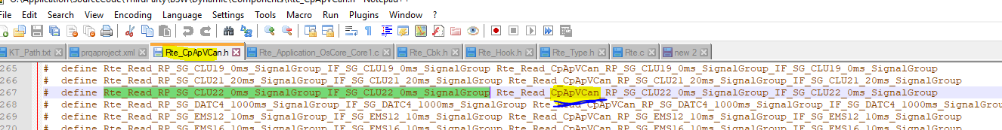 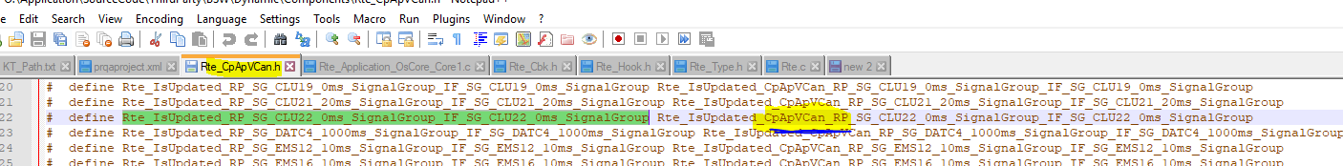

1. Performing mapping in Configurator

* Without mapping in ECU Composition Port Prototype RP_SG_CLU22_0ms_SignalGroup

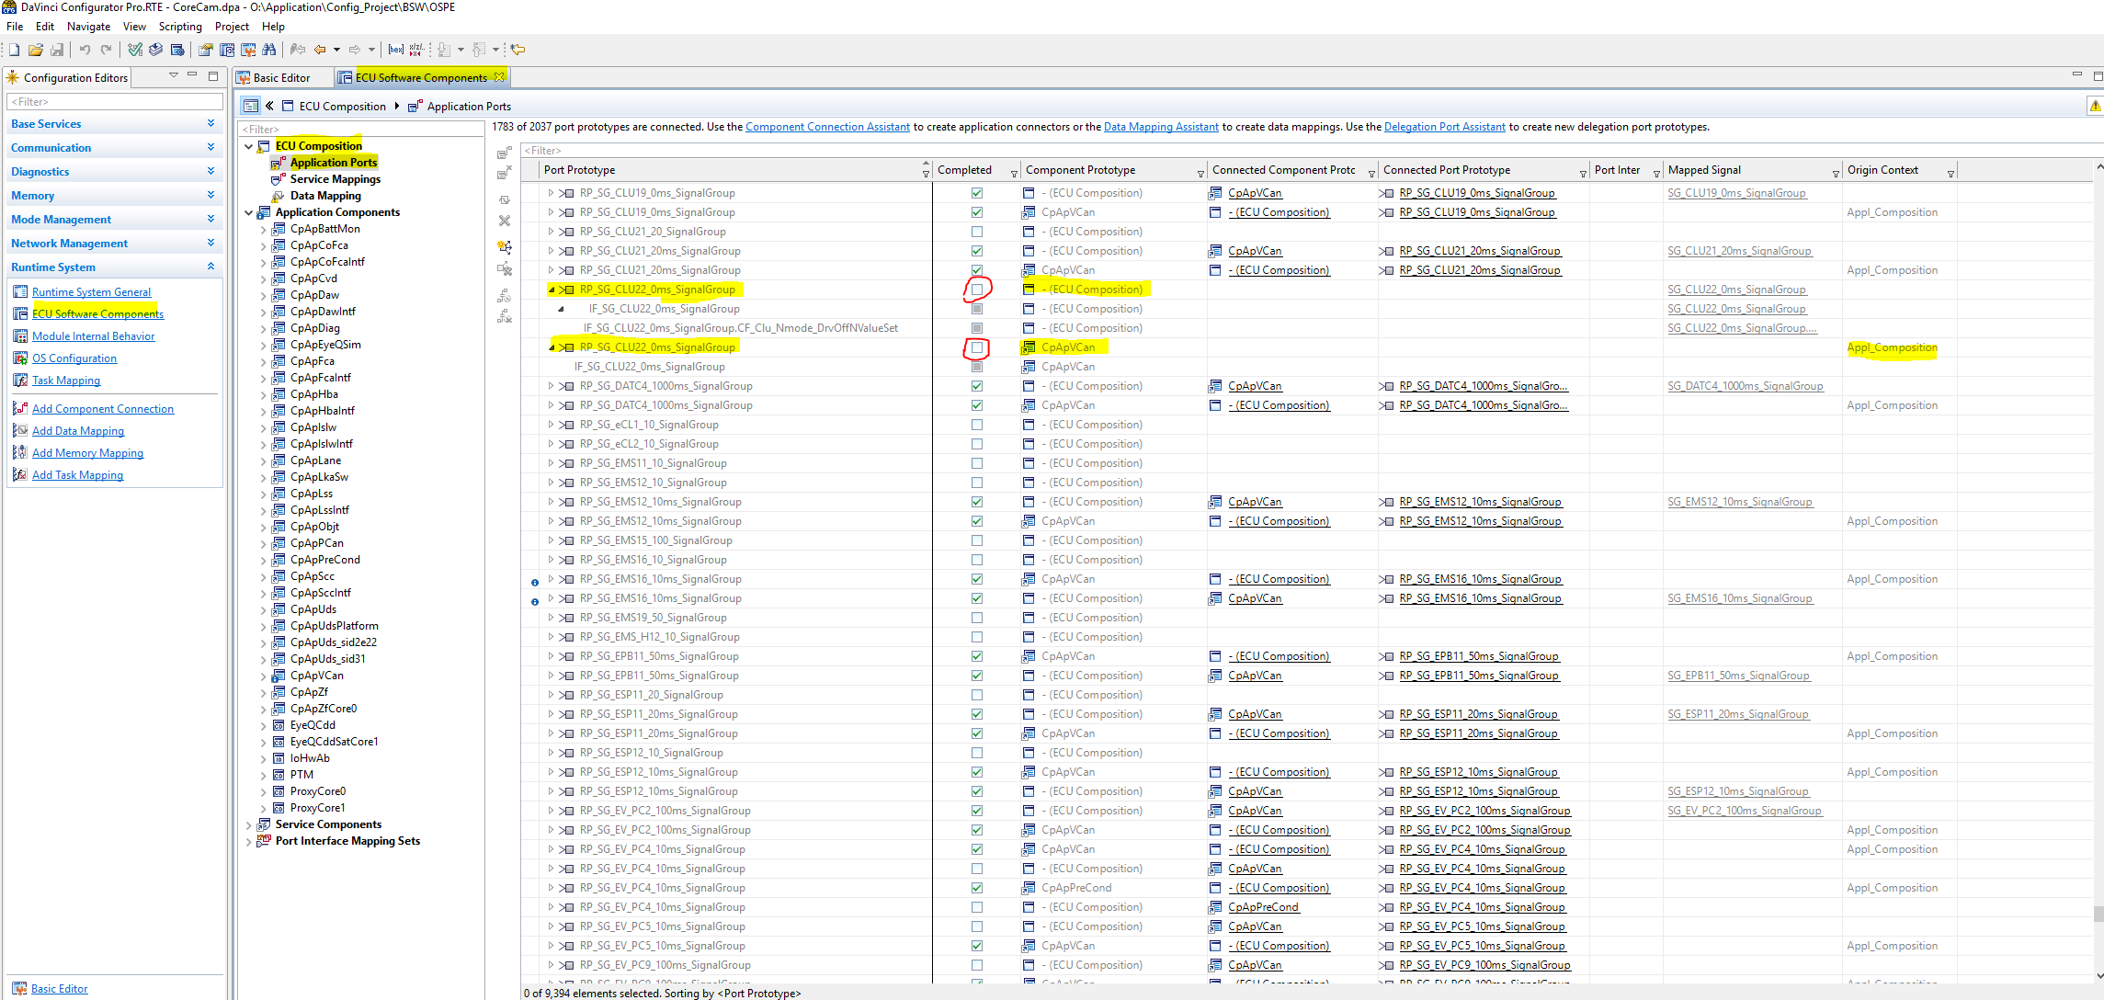

* Without mapping in Application Components CpApVCan Port Prototype RP_SG_CLU22_0ms_SignalGroup

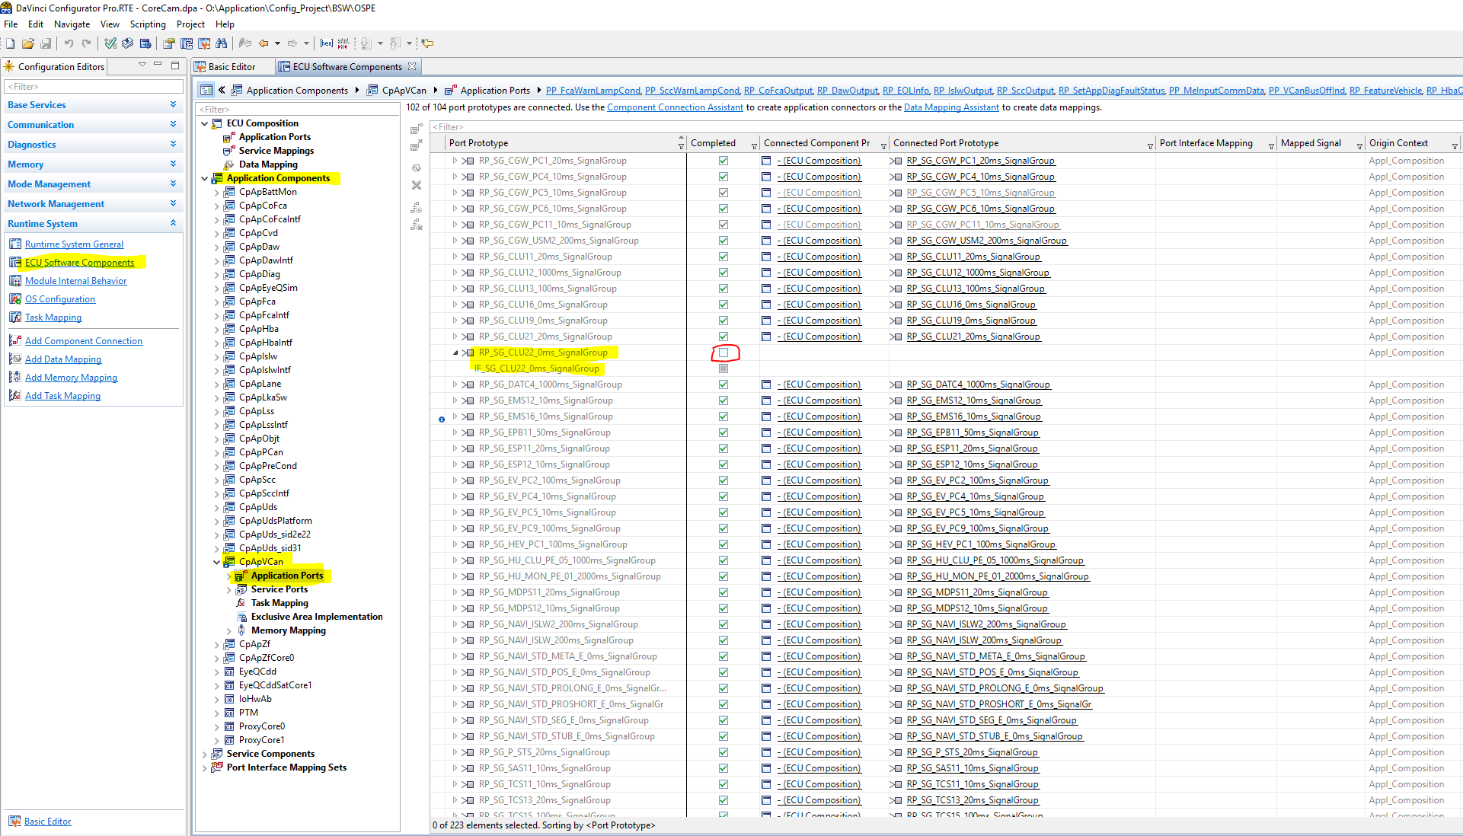

Mapping CpApVCan Port Prototype RP_SG_CLU22_0ms_SignalGroup, by Right click on Port Prototype and select Connect or in top level Component Connection Assistant is available

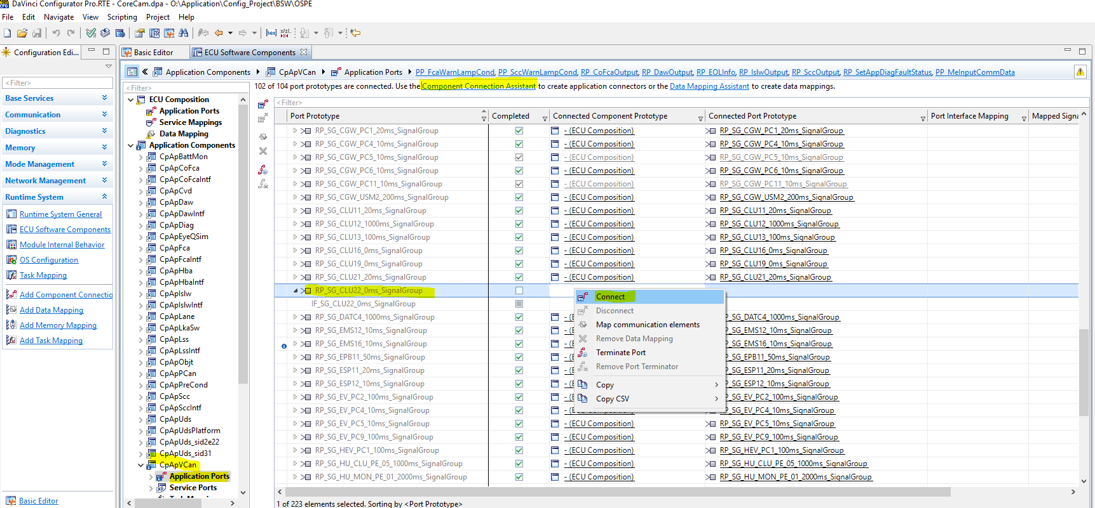

Once the connect menu open, connect CpApVCan Port Prototype (RP_SG_CLU22_0ms_SignalGroup) to ECU Composition Port Prototype RP_SG_CLU22_0ms_SignalGroup as shown below image

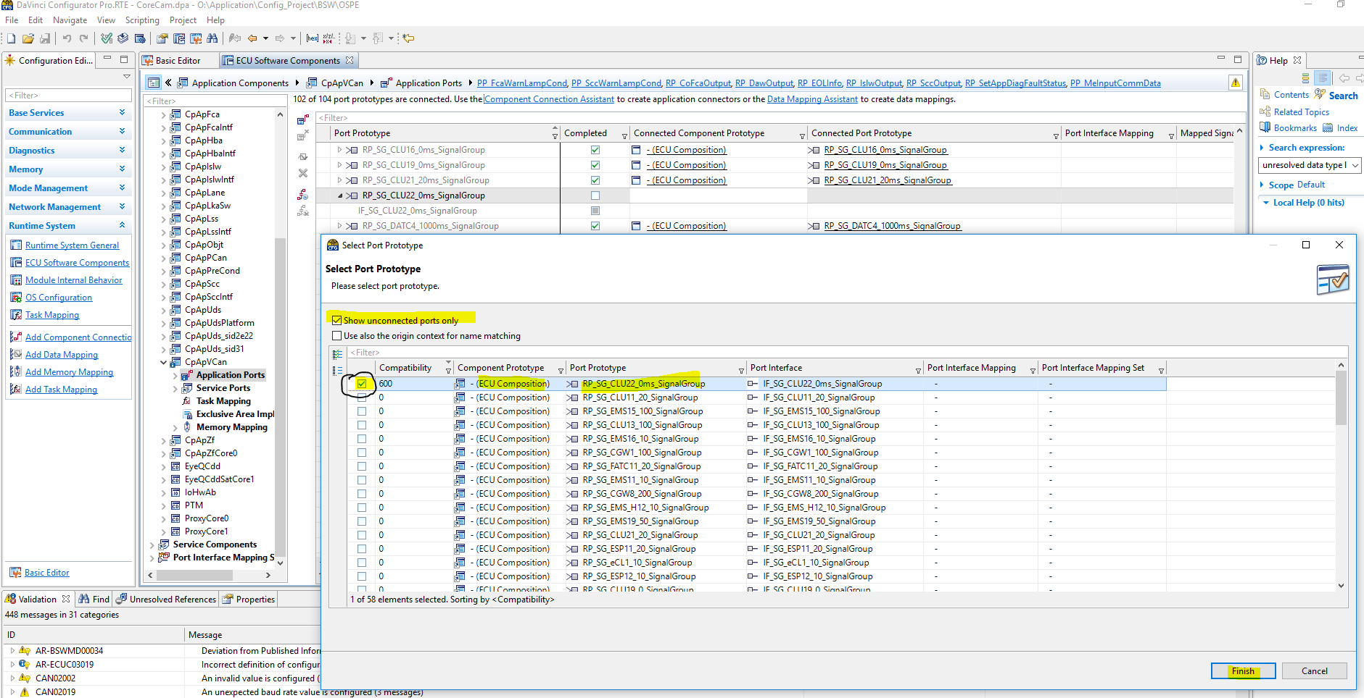

After connection of Port Prototype in CpApVCan

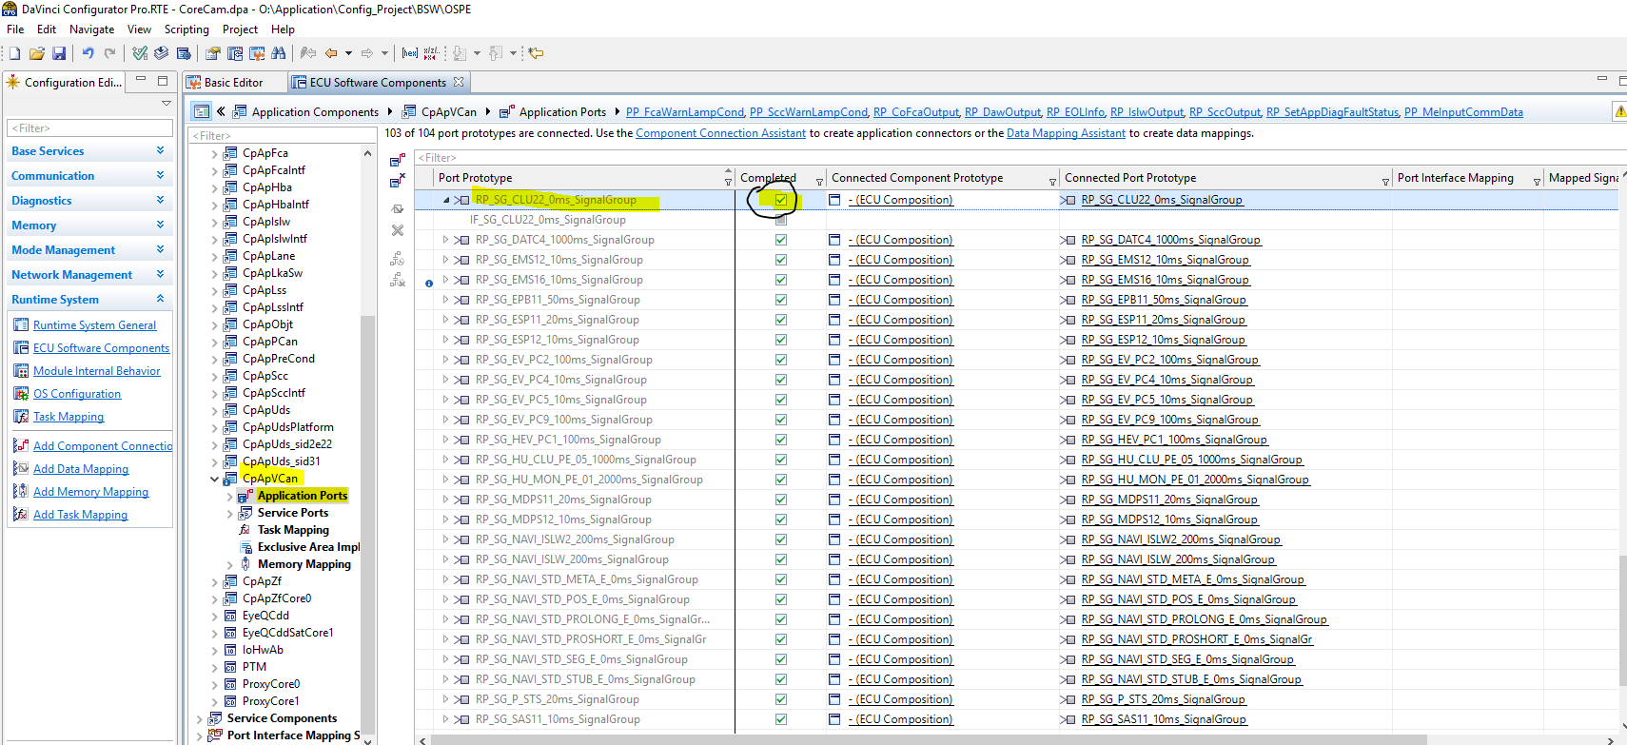

After connection of Port Prototype in ECU Composition

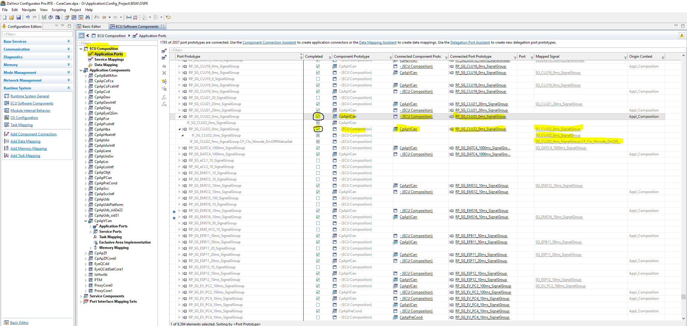

After this once the generation of code then below file updated/Generated

1. Rte_Application_OsCore_Core1.c --> unconnected to connected
2. Rte_Cbk.h --> This file generated
3. Rte_Hook.h --> some lines added
4. Rte_Type.h --> some lines added
5. Rte.c --> New function added

1) Rte_Application_OsCore_Core1.c

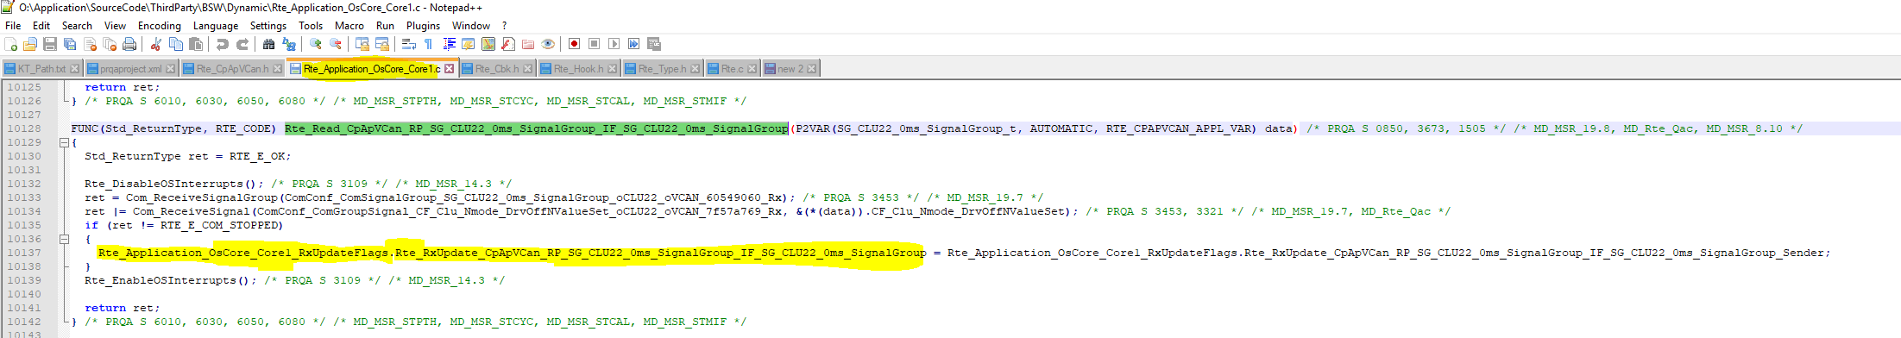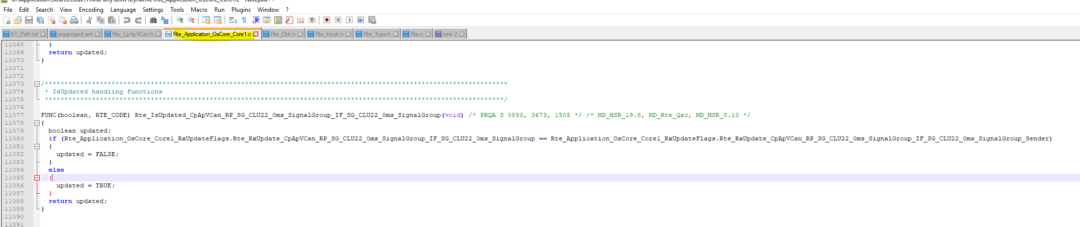

2) Rte_Cbk.h

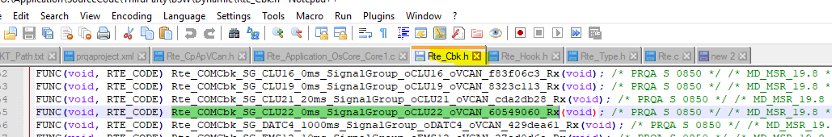

3) Rte_Hook.h

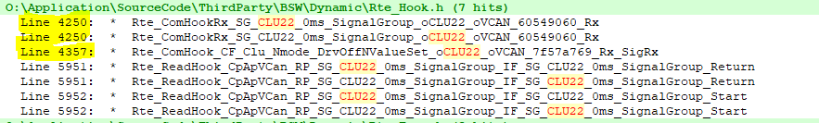

4) Rte_Type.h

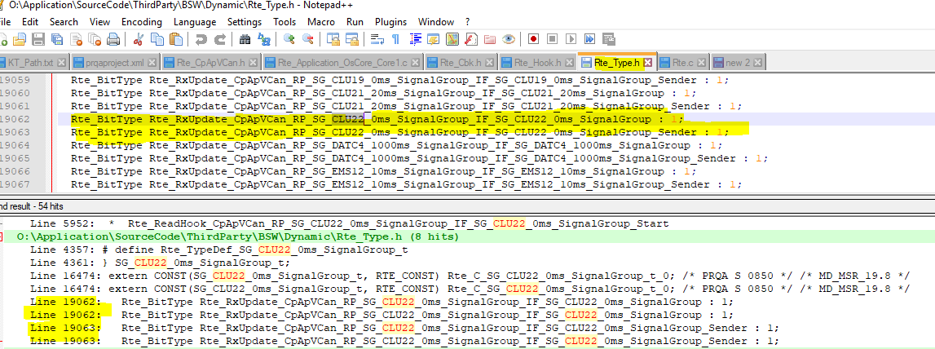

5) Rte.c

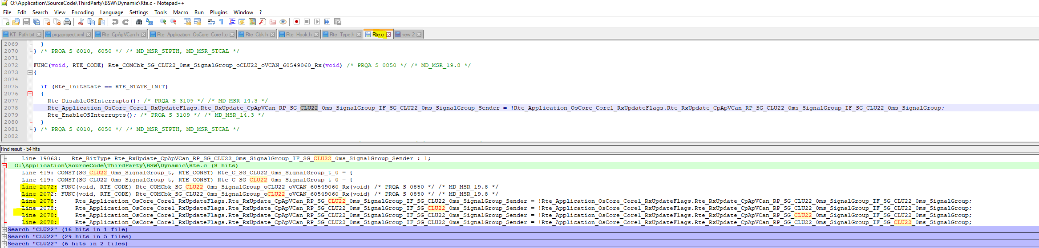

**CHAPTER 2 :** **Add New Signal**

Suppose message LKA11(0x340) have added new signal “Nmode_DrivingSafetyOff_Status”, as shown below

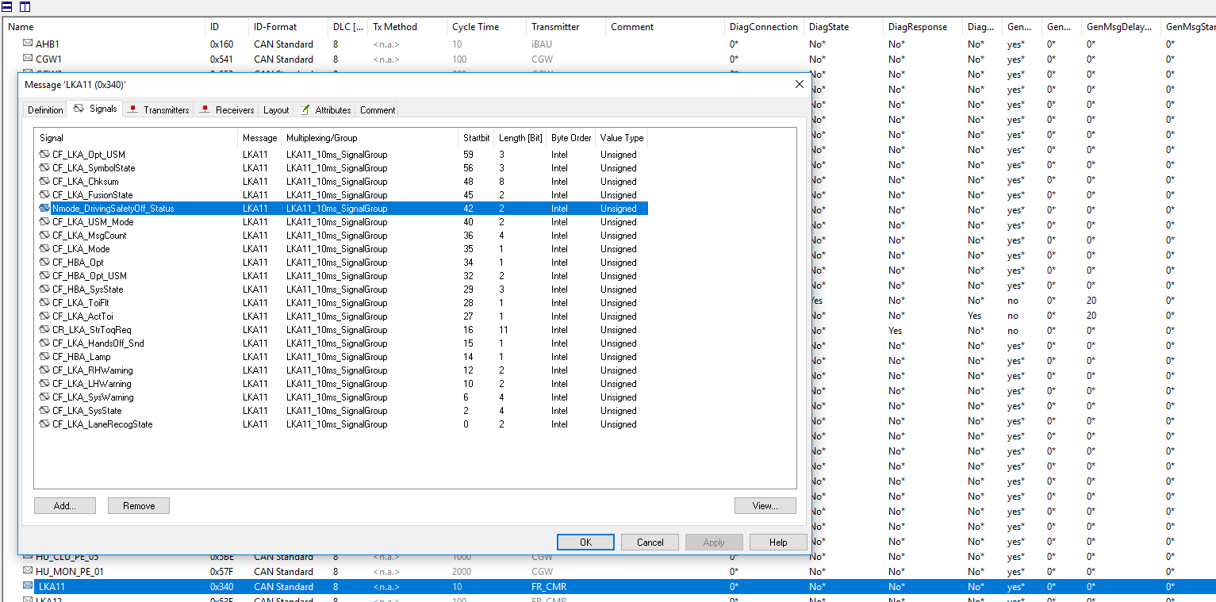

1. As message LKA11 is already available and it’s path’s are already created in Configurator and developer ,

When we are importing the DBC and update configuration this signal will available in COM module,

In COM module we need to check Signal Access property, by default it is ACCESS_UNCLEAR and we need to change as per our requirement( ACCESS_NEDDED_BY_SWC_OR_COM). Please check image for the same

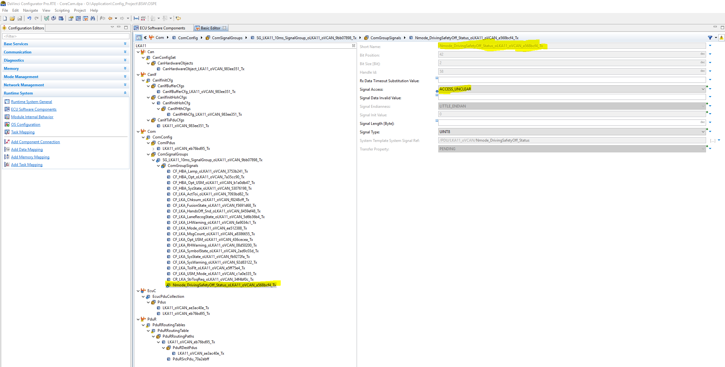

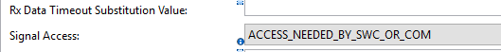

Please Check LKA11 reference in Rte_Application_OsCore_Core1.c

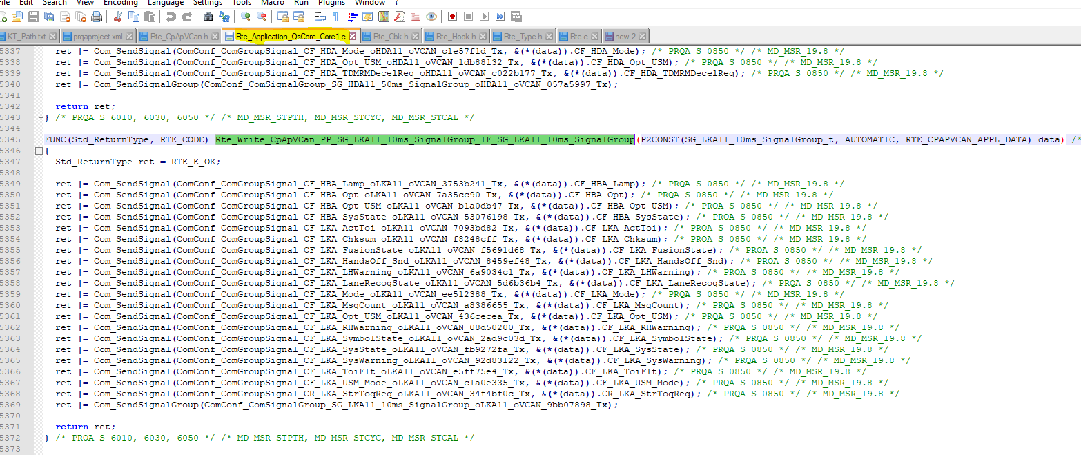

Rte_Hook.h

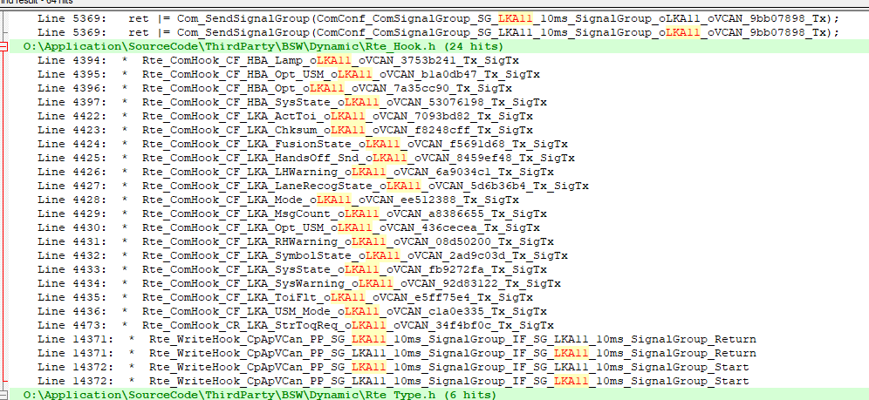

Rte_Type.h

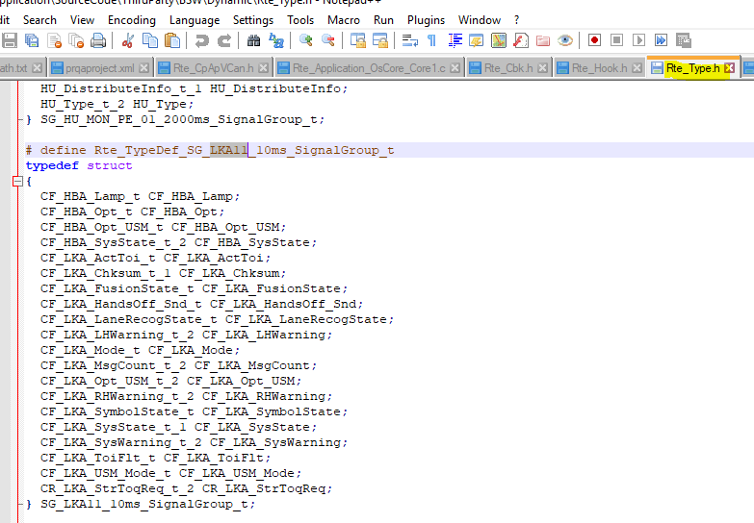

Rte.c

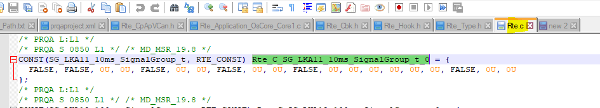

* In Data Mapping Signal View Mode ( ~ )

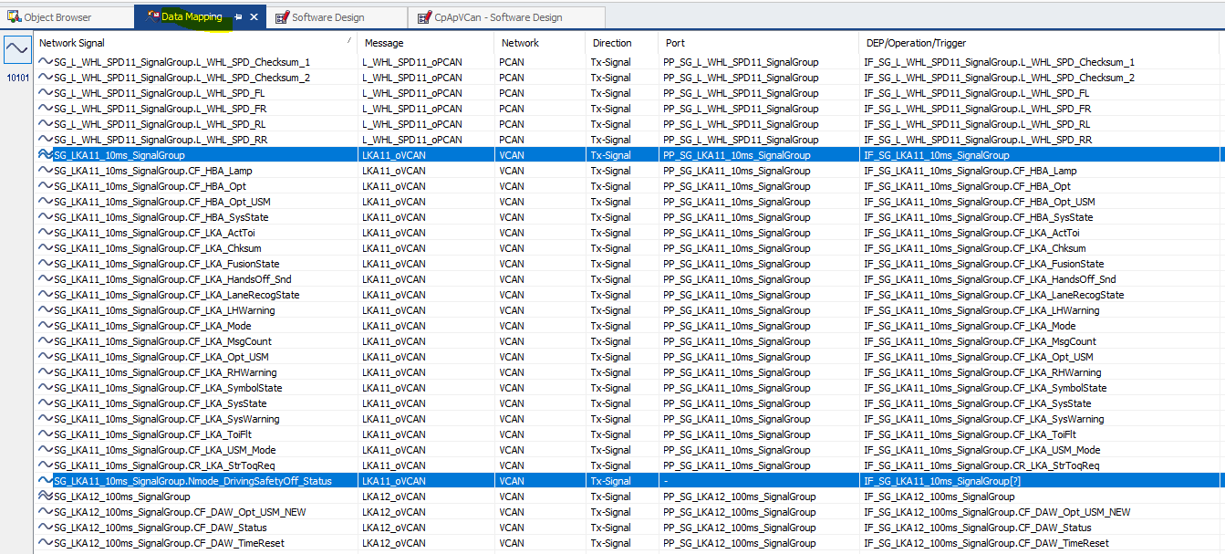

* In Data Mapping Port Element View Mode(10101)

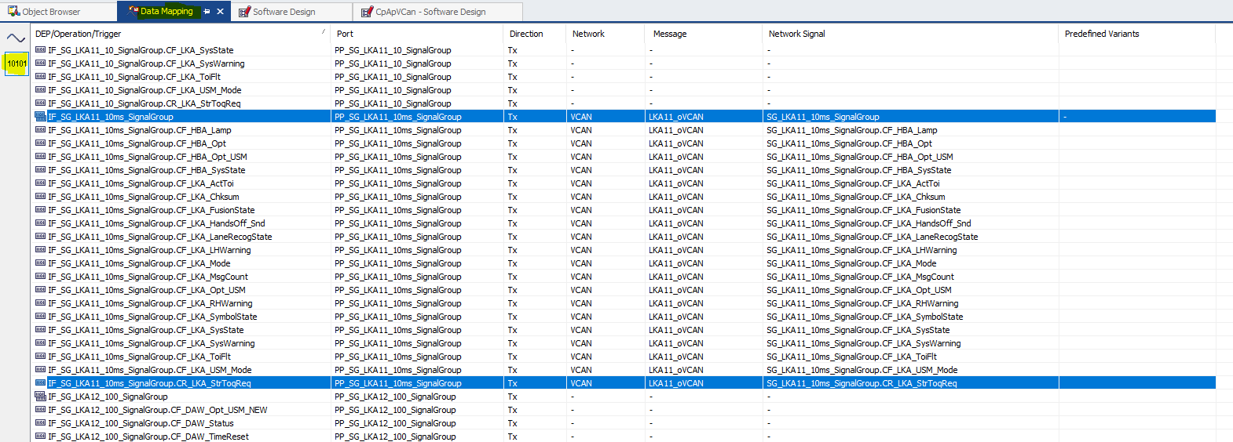

1. Right click on Signal Group (SG_LKA11_10ms_SignalGroup) and chose option as

Adapt Data Element to match Signal , due to this it will adapt all signal which are added/deleted ,in our case one signal added(Nmode_DrivingSafetyOff_Status)

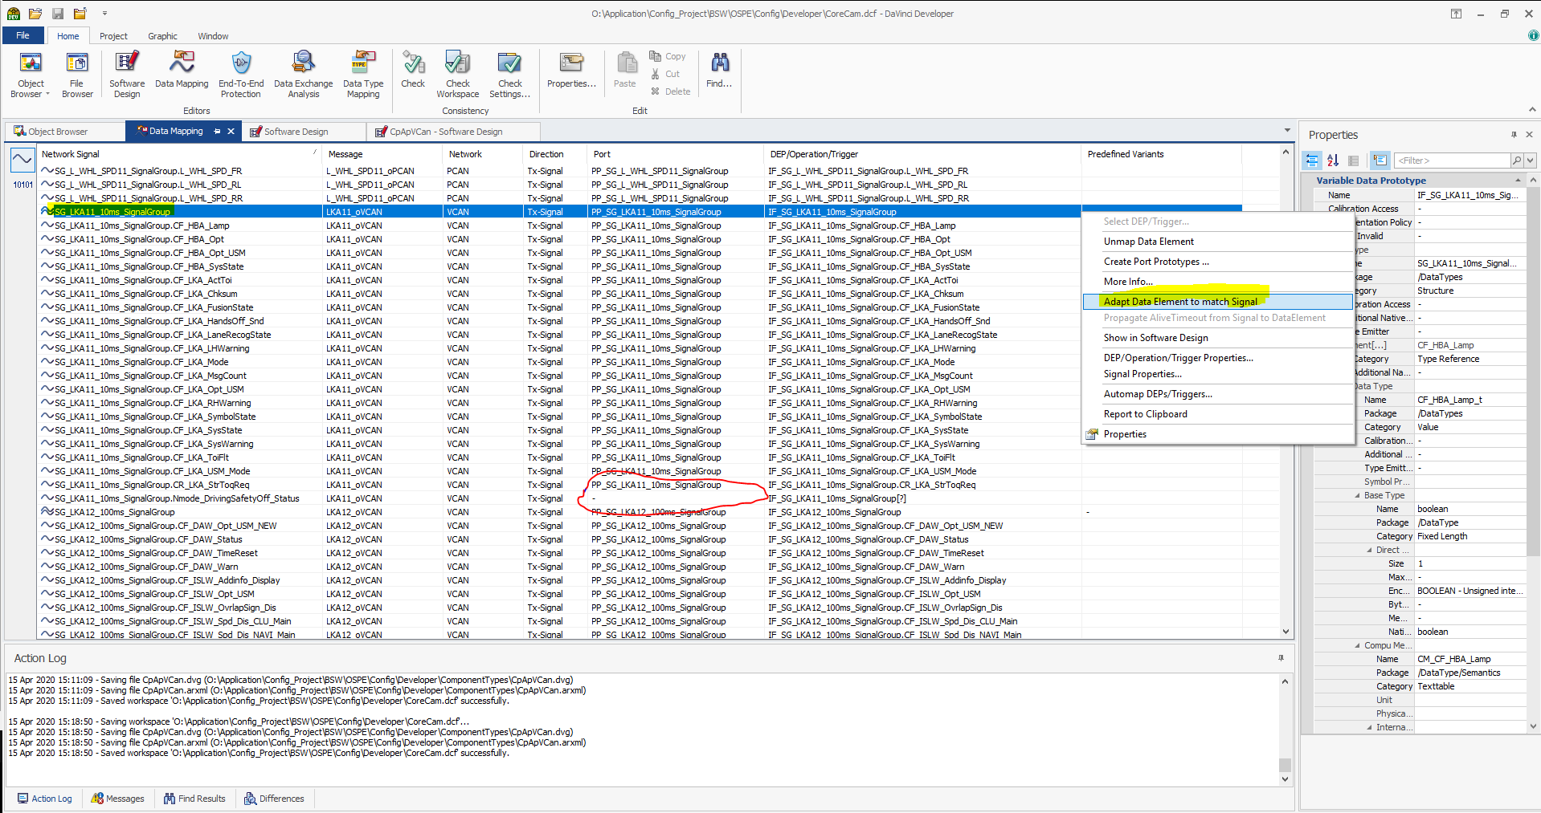

* Check after adaption Signal View Mode ( ~ )

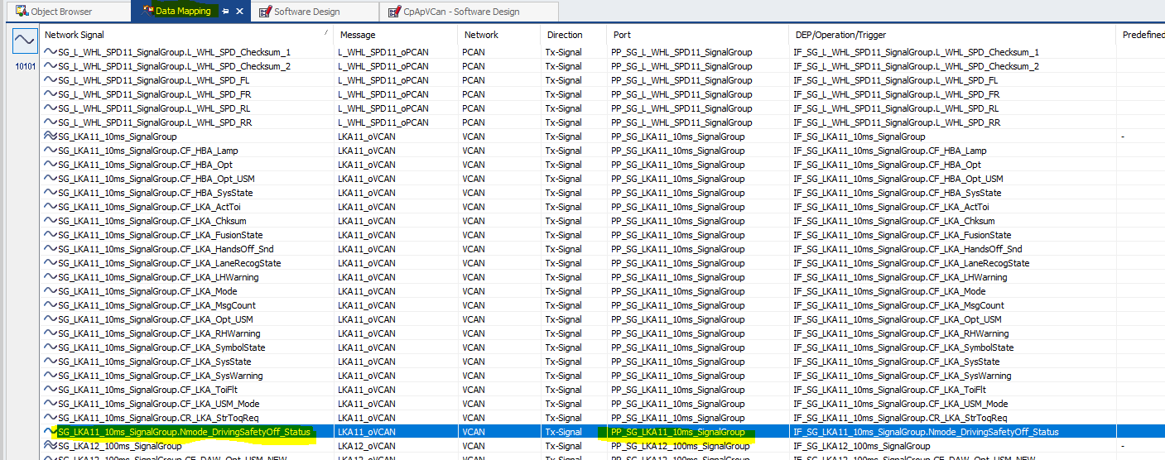

Port Element View Mode(10101)

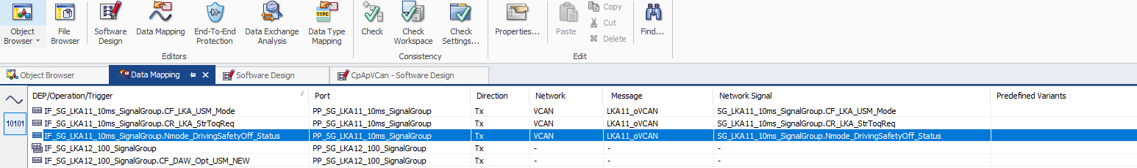

1. Synchronize configuration and generate ,it will give error because Port Prototype **not updated** as per latest Data

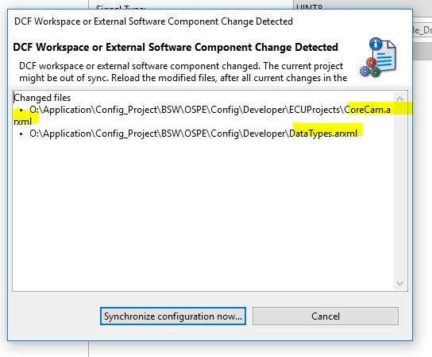

1. When we Adapt Data Element to match Signal that type time Implementation Data Type (SG_LKA11_10_SignalGroup_t) and Port Interface Updated as per new element/Signal,

But Port Interface is **not updated**, so we need to take care of that

Implementation Data Type

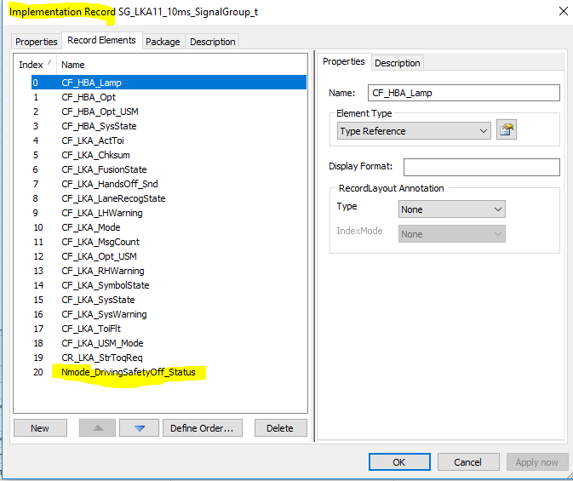

Port Interface

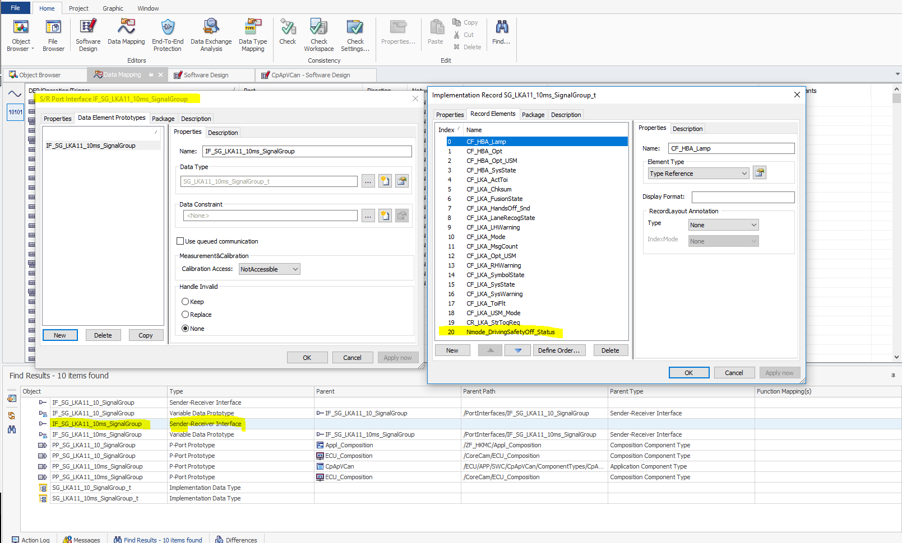

1. So how many places this interface(IF_SG_LKA11_10_SignalGroup) ,

Port Prototype is used in that places we need update it once again

In below Image (PP_SG_LKA11_10_SignalGroup) for CpApVCan and ECU_Compostion

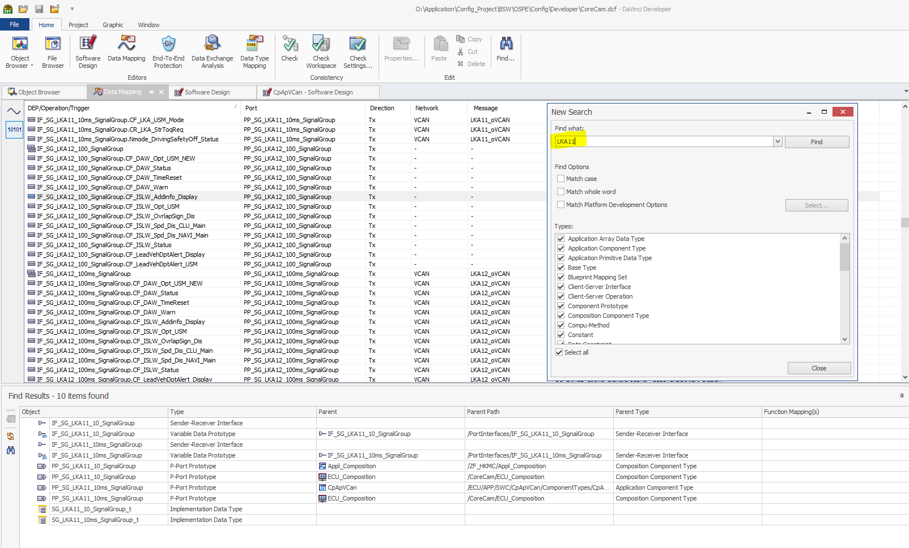

* Port Protype (PP_SG_LKA11_10ms_SignalGroup) for ECU_Composition and CpApVCan ,Below step perform

Update Record element using Adopt Structure With Record Types

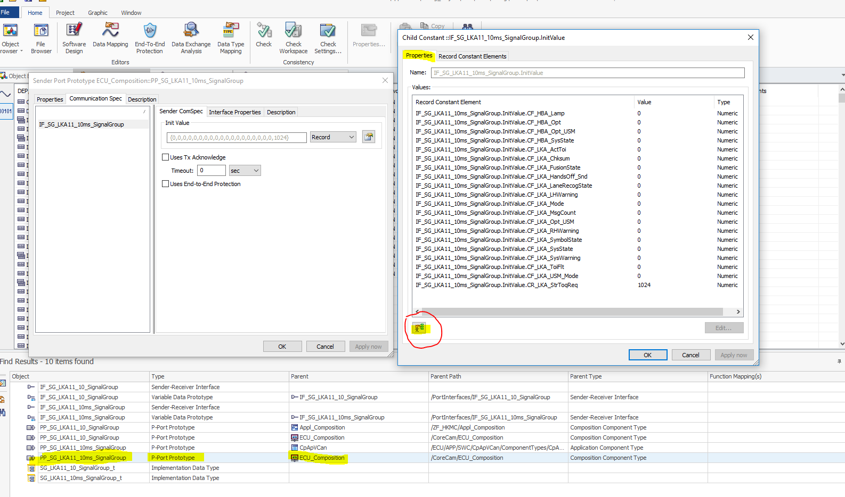

So, it will add new element(Nmode_DrivingSafetyOff_Status)

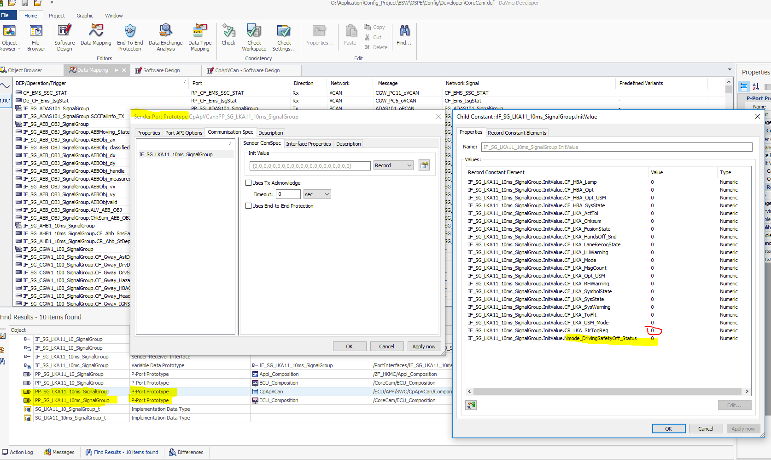

**Note:**

When we perform Adopt Structure With Record Types that time all elements by default set to value as **0** ,so we need to assign proper value once again

In below image for element CR_LKA_StrToReq previously it is 1024 and now after default it set to 0

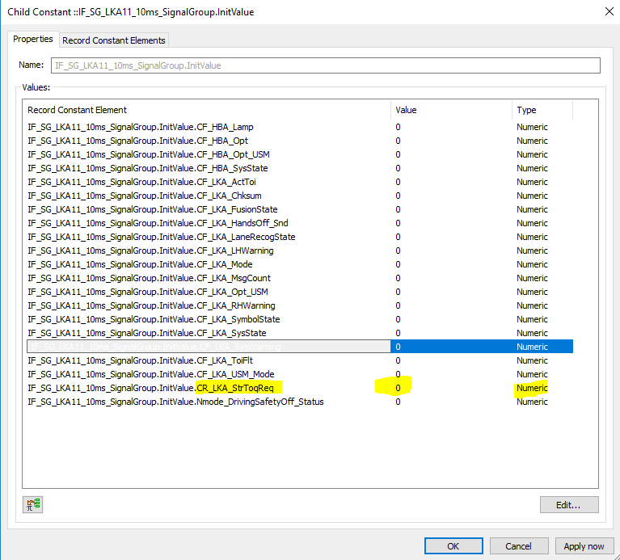

So we need to make initial value 1024 once again

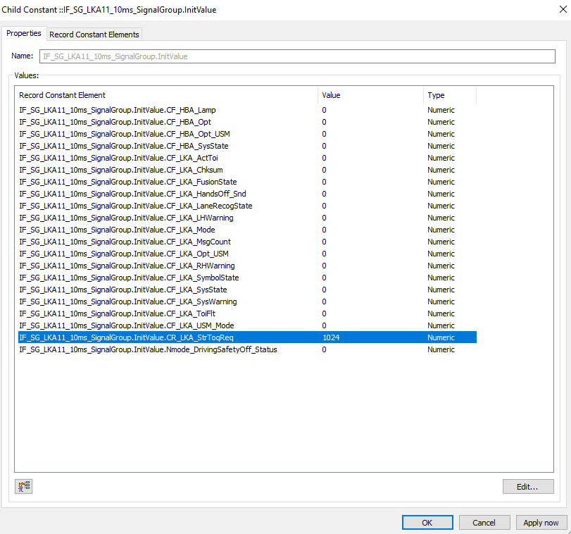

1. Once the synchronize and generation below files updated as

Rte_Application_OsCore_Core1.c

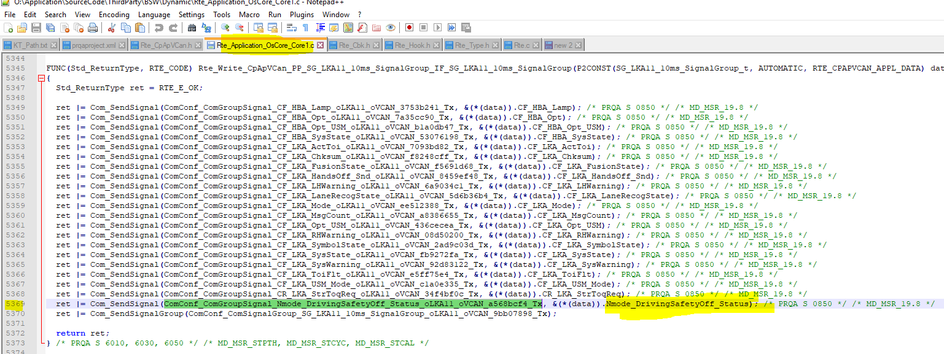

Rte_Hook.h

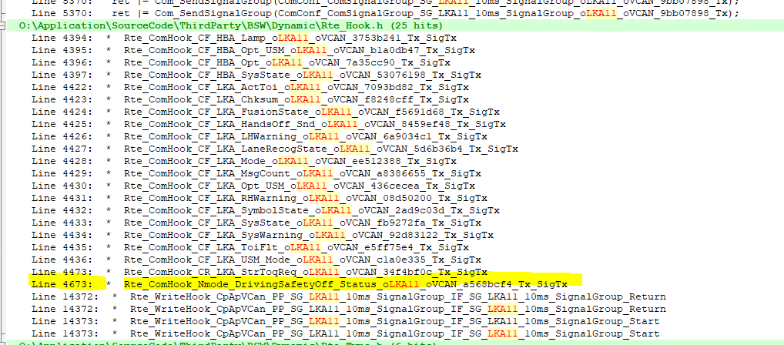

Rte_Type.h

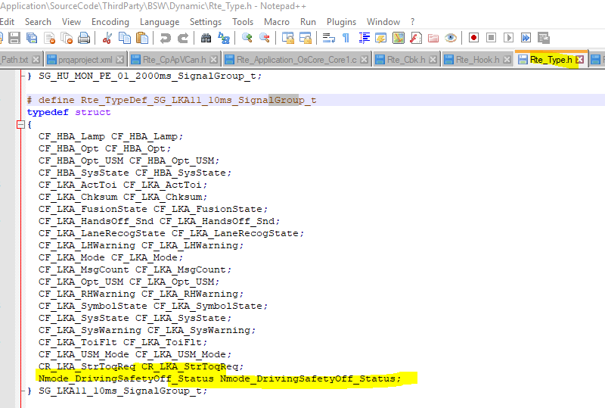

Rte.c --> One Element(last) added

